Friendship News, April 2020
First Congregational United Church of Christ, Brainerd
An Open and Affirming Congregation
Church office hours: Wednesday - Friday 8am 12:00pm
Office phone 218-829-2528 Office E-mail uccbrainerd@gmail.com Pastor’s E-mail: pastorleslieucc@gmail.com Website: www.uccbrainerd.org
To schedule a 1 to 1 with Pastor Leslie: www.calendly.com/pastorleslieucc/1to1
No matter who you are, or where you are on life’s journey, you are welcome here.

Pastor’s Pen – Separated, But Not Alone, in the Wilderness
I can’t believe how much the world has changed since our last newsletter. Since our last newsletter, the new coronavirus, Covid-19, has spread around the world, hundreds of thousands of people have become ill and tens of thousands of people have died. This is a difficult and challenging time unlike any we have seen in our lifetimes. It can feel overwhelming to live in this new reality and as I am writing this article on March 27, 2020, that new reality is just beginning to unfold. It is important for us to name this reality and all the feelings that we are experiencing as a result – fear, denial, grief, anger, anxiety, sadness, helplessness as well as hope, perseverance, compassion, and love just to name a few.
We are in uncharted territory, a wilderness time. A time that is unlike anything we have experienced before. Wilderness times in our scriptures are times of change, times of challenge, times of faith and trust. One of the earliest and most well-known examples of a wilderness time in scripture is the journey of the Hebrew people out of slavery in Egypt through the desert until they arrive decades later in Canaan. You might remember that in Exodus 16 the people being led by Moses start to panic. They are in the second month of their journey and they are running out of food. God responds by sending manna for them: food from heaven. But God only sends enough for one day a time. Those who gathered more than they needed for the day discovered that the manna would turn foul after one day and so the gathering began each morning, one day at a time. On the eve of the Sabbath day, they were told to gather two days’ worth. This manna did not turn foul after one day, allowing them a time to rest and renew. Even in a time of extreme crisis, the commandment to keep the Sabbath remained in place.
We find ourselves in the wilderness now. And not a metaphorical one. We are, all of us, in a place we’ve never been before. The path is dimly lit and untraveled. Many of us are having trouble sleeping. We wonder what the next day, the next week, the next month will bring. We worry about our friends and families, about our jobs and our futures. Our hearts are breaking for people suffering around the world. In this wilderness, it is important to take things one day at a time.
Remember, there is manna in this wilderness. That manna comes in many forms these days – walks in the fresh air, connecting with friends and family by phone and video chat, taking time for meditation and prayer… Find what nourishes you and gather enough for today. And please don’t forget that God also gives us the gift and command of Sabbath. At least one day per week, we are told to rest from our labors. God goes with us on this journey in the wilderness, loving us into a future that we hope and pray will be filled with more justice, more peace - a world more closely aligned with God’s vision for creation.
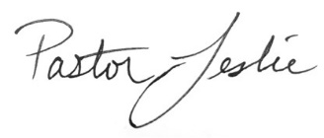
With Peace,

~ Opportunities to Know and Share God’s Love ~
Helping the community
Your Church Council voted on Wednesday to allow the Pastor's Discretionary Fund to be used to assist church members and others in the Brainerd area who are experiencing financial distress during this time. If you would like to make a donation to this fund, you can mail a check to the church and write "Discretionary Fund" in the memo line. Decisions about disbursement of funds will be handled by the Executive Committee.
If you are in need of assistance, please email, call, or text Pastor Leslie. Let her know what your situation is and how the church might be of help.

Sharing Bread Soup Kitchen is no longer serving daily meals. Instead, they have teamed up with Operation Sandwich to put together bags of food for the guests at the Soup Kitchen. Every Thursday the bags are handed out from 5:30-6:00 p.m. at the Soup Kitchen location. If someone can't make it during that time, they can contact Operation Sandwich 218-829-2619 or Bridges of Hope at 218-297-4223 to make other arrangements. While this is not ideal, it has been decided that it is going to be best to keep the guests and volunteers as safe as possible.

4th Sunday Special Offering for April– Bridges of Hope
Bridges of Hope is responding to the Covid-19 Crisis here in the Brainerd Lakes area by taking action on multiple fronts. BOH is the fiscal agent for Operation Sandwich, an organization providing food for school children while schools are closed but also working with the Sharing Bread Soup Kitchen to provide food bags each week to anyone in need.
Bridges of Hope is also working to provide financial assistance to those who are having a hard time paying rent, and is talking with utility companies to make sure services can continue even if customers are not able to pay.
To donate to the 4th Sunday special offering, you can mail a check to the church and write Bridges of Hope in the memo, you can donate via PayPal and write Bridges of Hope in the comments, or you can donate to Bridges of Hope directly by going to https://www.bridgesofhopemn.org/donate or by mailing a check to
Bridges of Hope
PO Box 742
Brainerd, MN 56401

Habitat Build Update
The site has been cleared for Dale and Katie Johnson’s home at 14802 Lynwood Drive in Baxter! Through their Faith Build partnership with Lakes Area Habitat for Humanity (LAHH), and Thrivent, the Johnson’s dream of homeownership is becoming a reality. The concrete will be poured once road restrictions are lifted. That means we could be scheduling volunteers to help with the build by mid-May!

Our First Congregation UCC of Brainerd partnership is so important to the success of the Faith Build. During these uncertain times it has become a little tricky as plans for fundraising and recruiting volunteers have been sketchy. Please continue praying for the Johnson family and the success of this project. If you would like to contribute to the Johnson’s project, you may do so either through our church Pay Pal and please write in the comment box “Habitat Build”, or send a check to the church office and write “Habitat Build” in the memo. So far we have raised $300, let’s keep it going!

Of course, with the recent developments regarding COVID-19, all of this is subject to change. We will continue to monitor CDC & government recommendations/orders. We will do our best to keep you updated as the project moves forward. I will be connecting with you all when it comes time for recruiting volunteers for the build, looking for dates and skill sets once I hear from Habitat. Please contact me if you have any questions.
Ellie Burkett prairiesmoke757@gmail.com, (218)232-4827.

April Birthdays

Izzy Armstrong April 1
Krystal Graf April 4
Alice Widmark April 9
Hans Stadem April 13
Bonnie Crum April 14
Dan Hegstad April 14
Joey Halverson April 15
Randy Crow April 18
Emma Ferrie April 23
Coleen Carder April 24
Austin Newgord April 24
JoAnne Nelson April 24
Donald Utzman April 24
Mitch Crum April 26
Lori Howe April 27
Cheri Maxwell April 28

Coronavirus/Covid-19 and Our Church - An Update from Pastor Leslie
Dear church family,
This week, Gov. Walz issued a "Stay at Home" order for the state of Minnesota. Since the church has already shifted the vast majority of church activities have either moved online or have been postponed or cancelled, this stay at home order will not mean many additional changes for us. The one big change we are making, is closing the church office. Terri and I will be at the church on occasion for critical business, like receiving mail (and your generous donations) but the office will not be "open." The doors to the church will be locked. We are able to check voicemail and email remotely and will be doing so during our regular business hours of Wednesday - Friday between 8am - 12:00pm. You will get the voicemail when you call the office, but please leave a message and one of us will get back to as soon as we can. As usual, if you have a pastoral emergency, please call me on my cell phone. (The number is in the directory and on the outgoing voicemail message for the church.) Please also don’t hesitate to call or text me on my cell during my work week (Wednesday – Sunday) between 8am and 6pm if you need non-urgent pastoral care. If you get my voicemail, please leave a message and I will call you back as soon as I can.
Please Stay Home! We urge everyone to stay home as much as possible. Consider ordering groceries and other necessities online or over the phone and either picking them up or have them delivered. Ask for help! We have a few folks in the church who have volunteered to pick up groceries and medications for those who are in high risk groups or are not feeling well. Please contact me if you need assistance.
How Long?
One of the big questions on everyone's mind is how long will in-person worship and other in-person gatherings be cancelled? I wish I had a crystal ball to be able to answer that with certainty. The truth is that is seems we are still in the early stages of this crisis and we will likely need to continue to utilize social distancing for quite some time. It is looking certain that we will not be able to worship or gather in person through the month of April if not longer. This means we will not be together in-person for Palm Sunday or Easter Sunday. This is a sad thought for many of us, but the health and safety of our church members and the wider community is the priority. We will celebrate the resurrection, just not the way we have done it in the past. I will be working on putting together some worship experiences and resources for Holy Week as well.
I am in contact with many clergy in the Brainerd area, with the Minnesota Conference of the UCC, and colleagues around the country as we all continue to monitor the situation and determine how to protect our congregations and the communities in which we reside. As the situation continues to unfold, your Church Council and I will reassess what makes sense for our congregation and will keep you informed of any changes.
Worship
The current plan for worship is to continue using Facebook Live to broadcast worship. Instructions for accessing the Live Video are below. This is an evolving experience as I continue to figure out what works best for our congregation as well as my abilities with technology.
Worship Bulletins will be available for download each week by clicking here. The bulletins will be ready for download by Saturday morning. They are available in both Word and PDF formats and are labeled by date. You can download the document and print it at home or follow along on your screen.
We can also send the manuscript of the sermon and a copy of the bulletin in the mail each week as we have been doing for some of our home-bound members. Just contact Terri in the office. I will also continue to upload sermon manuscripts to the church website here.
For information about the outbreak from the Minnesota Department of Health, click here.
For Crow Wing County Updates, their Facebook page seems to be where they are posting updates: https://www.facebook.com/crowwingcounty.
We will post church-related updates to the church Facebook page and send emails to this mailing list.
How to watch Sunday worship on Facebook Live
A modified worship service will be broadcasted on the church Facebook page every Sunday at 10:00 am. Not sure how to access the worship service without a Facebook account? Keep reading... If you have a facebook account, start with step 1 and then skip to step 4
1. Go to https://www.facebook.com/uccbrainerd
>>> If you are not logged into an account, you MUST access Facebook with this complete url, either by typing it in or clicking on the link. If you just go to facebook.com you will not get past the login page. When you go to the link above, the page should look like this...
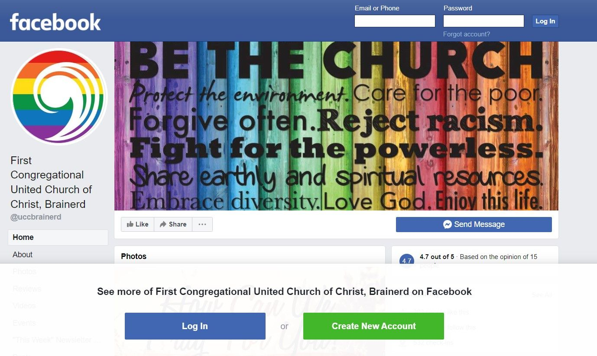
2. If you have an account, go ahead and login. But you do not have to log in or create an account. Just ignore that message at the bottom of the screen that says "See more of First Congregational United Church of Christ, Brainerd on Facebook"
3. Begin to scroll down the page. As you scroll, you will likely get a pop-up message like the one below that invites you to log-in or create an account. Click on the words "not now" to make the clear the message.
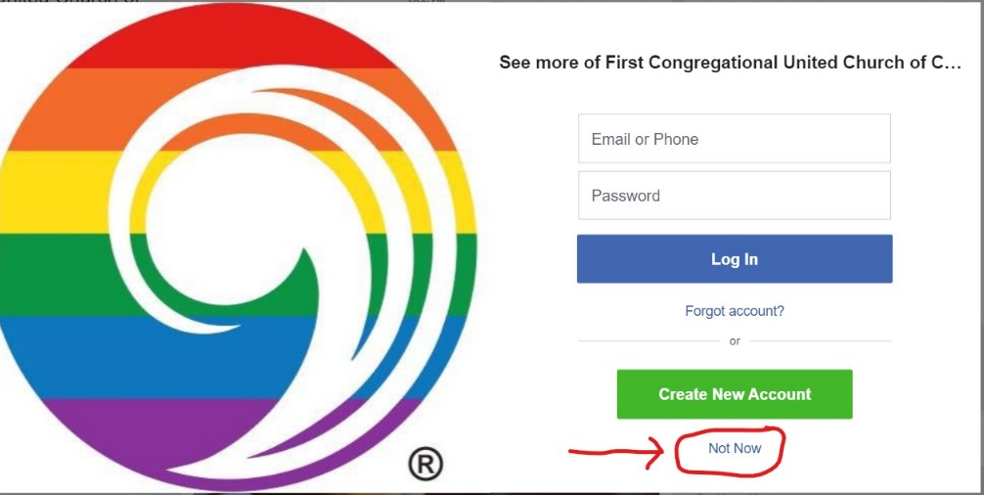
4. Keep scrolling until you get to the first Post. It should be the Live Video. If it is before 10:00am and you do not see the video, the feed may not yet be active. Refresh your internet browser again at 10:00am and look for the video. It should look something like the image below. (Note the little red box that says "Live")
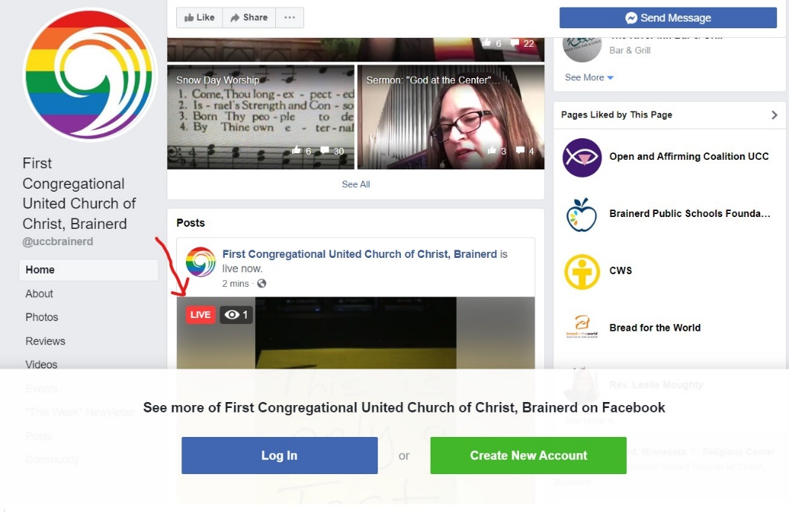
5. Click on that video and you will be participating in worship!
Live stream videos are saved and can be viewed at any time.
Peace be with you,
Pastor Leslie

What about Giving to the Church during the Coronavirus?
A significant portion of the church's financial support is received during worship on Sunday mornings. When we don't gather in person, our income takes a hit. We realize that for many of you, this is a time of financial uncertainty. If you are able to continue supporting the church with your financial gifts, we encourage you to do so. We may not be gathering in person right now, but we are continuing to Be the Church in new ways!
We also understand if you need to reduce your giving right now. If you are signed up for electronic giving and need to reduce the amount you contribute, please contact Terri in the office. If you are able to increase your giving to help cover the decrease we are likely to see, please also contact Terri in the office to make that adjustment.
You can now donate to the church online! We are now accepting your offerings and donations using PayPal. You do not need to have a PayPal account to make an online donation with a credit card. To contribute using PayPal, click here: https://www.paypal.me/uccbrainerd

Highlights from the March 2020 Council Meeting (via Zoom Conference)
Present: Tracy Lyons, Barb Stokke, Bobbie Gorron, Deb Griffith, Judy Whiteman, Sue Hadland, Lowell Johnson, Alvin Velsvaag, Cassie Lyons, Terri Chidester, and Rev. Leslie Moughty.

Updates from committees and teams:
- Treasurer: The final 2019 year-end financial report is almost complete. Clearer protocols for the new Memorial account need to be determined and put in place.
- Trustees: The handicap entry and the keyless entry system have been installed and are working properly. Phase 2, installation of the front door emergency panic paddles, will begin soon, and new keys will be made for the remaining outside entries.
- Christian Ministry: Maundy Thursday service and soup supper is cancelled and possibly shifted online. Committee is looking into replacing the pew cushions.
- Christian Education: CE is working on fundraising for summer youth experiences.
- Members at Large: Seeking members to fill vacancies on committees and the Council. Upcoming committee and Council vacancies for 2020-2021 include Asst Moderator, Christian Ed, Christian Ministry, Trustees, Stewardship, and the Memorial Committee.
- A new Creation Care group will be meeting virtually.
- First Congregational’s resolution for the MN Conference to become W.I.S.E. was submitted.
Motions:
- New process for counting and depositing offerings during the COVID-19 shutdown (Deb and Tracy will alternate coming into the office to count with Terri each week) - Approved.
- Establish a PayPal account for the church to receive online donations - Approved
- Use the discretionary fund to help people in need during the coronavirus crisis with necessary decisions to be made by the executive committee and Pastor Leslie - Approved
- Organists and choir director continue to receive their salaries until the next Council meeting. Decision to continue for will be reassessed with updated financial information. - Approved
- Allow outside groups who meet at the church to continue using the church if they choose to. They are asked to clean their spaces before leaving with the provided supplies. – Approved.

The next Council meeting will be April 15 at 7:00 pm. – Virtual Zoom
The May Council meeting will be held May 13, one week earlier than usual, to accommodate the May 17 Annual Meeting. Committees will need to adjust their meeting date if they want to meet prior to the Council meeting.
Online Gathering Opportunities
We may not be gathering in person, but that doesn't mean we can't get together! Check out these opportunities to connect with your church throughout the week. Changes or additions may be made to these as the weeks progress, so stay tuned!
"Daily Bread" with Pastor Leslie on Facebook Live: Tune in at Noon each day for a short time of prayer, pause, and reflection via Live stream on Pastor Leslie's facebook page. Click here at noon each day to participate live or to view recorded videos at any time: facebook.com/revleslieucc
Prayer Circle via Zoom: Join our prayer circle for a time of fellowship, conversation, and prayer from 10:00 am - 11:30 am every Wednesday. Click here to participate: https://zoom.us/j/143352001
You can also participate by phone! Call 1-312-626-6799 and enter meeting code: 143-352-001 and you will be connected!
Lenten Book Study via Conference Call: Study and discussion of The Universal Christ by Richard Rohr continues each Sunday through April 5th. Join us through a free conference call at 8:30 AM. Use 605- 475-4000 as the call in number and 421487# as the access code.
Bible Study via Zoom: Study the book of Mark, virtually online with Pastor Leslie this Lenten season from 5:30pm - 6:30pm each Wednesday evening through April 1st. Click here to participate: https://zoom.us/j/877821134
You can also participate by phone! Simply call 1-301-715-8592, enter meeting code 877-821-134
and you will be connected!

First Congregational UCC Event Changes
Volunteer Appreciation Luncheon - Postponed until further notice
Cook’s Annual Fundraiser Dinner - Postponed until further notice
All-Church Book Study: Five Practices of Fruitful Congregations - This book study is on hold until we have a better idea of what the needs of the congregation will be in the coming months. Stay tuned!
Brainerd Lakes Area Events
Update from the Sharing Bread Soup Kitchen
We have decided that in order to further protect our volunteers and guests we need to change what we are currently doing. Guests still need food, but we need to limit the amount of contact that is taking place between volunteers and guests, especially with the “Shelter in Place” that began on Friday, March 27th. We will be giving our guests a bag of food.
We are partnering with other organizations in order for this to happen. Sharing Bread Soup Kitchen and Operation Sandwich have been working together this week and will continue to do so in order to make this happen. The Outreach Program has given us a bunch of meal packs also. The YMCA helped us get the resources from Operation Sandwich to the Soup Kitchen. Teamwork is a beautiful thing!
Want to help? We would love for you to partner with us in helping get food out to the people in our community. We are welcoming any non-perishable (non-expired) food items. These items can be dropped off at the soup kitchen (218-829-4203), Operation Sandwich (Bethlehem Lutheran) or Bridges of Hope. If you would like to make a monetary donation, to help cover the cost for these bags of food, you can go to these places to make a donation:
www.sharingbread.com or www.bridgesofhopemn.org/donate (Please indicate that you would like your donation to go to Operation Sandwich)
Pickup days for the guests will be every Thursday from 5:30-6:00pm. We will not be open for meals at all the rest of the week. Guests that do not make it to the soup kitchen during the Thursday time slot can contact Operation Sandwich or Bridges of Hope to set up alternative ways to get the food
2020 Women Making Waves Award - Postponed until Fall. Becky Twamley will be honored at the celebration dinner
The Rapidly Changing Climate Presentation - Cancelled
Marcia’s Retirement & Dan’s 65th Birthday - Postponed until further notice!

Summer Youth Camp 2020

Sunday, June 28th - Wednesday, July 1st

Camp Onomia - 14202 Shakopee Lake Road, Onamia MN 56359

It is unclear at this time if this event will be able to go on as scheduled.
Stay tuned for updates.

Church Calendar April 2020
Sunday | Monday | Tuesday | Wednesday | Thursday | Friday | Saturday
 | Office Closed on Mondays | Office Closed on Tuesdays | Office Open  8:00 am – 12:00 pm | Office Open  8:00 am – 12:00 pm | Office Open  8:00 am – 12:00 pm
 |  | . | 9:30 Prayer Circle - 1 Virtual  5:00 Lenten Bible Study-Virtual  7:00 AA | 2  4:00 Girl Scouts #43 | 3  10:30 Book Group-Cancelled until further notice | 4
5  8:30 Book Study Virtual  9:00 Brainerd Friends  10:00 Worship-Virtual | 6  4:00 Girl Scouts  6:00 Tai Chi-Cancelled  7:00 BACP | 7  2:00 Emotions Anon. cancelled until further notice  5:30 Overeaters Anon. | 8  9:30 Prayer Circle-Virtual  12:00 Men’s Group-Cancelled until further notice  7:00 AA | 9  3:00 Trustees-Virtual  5:00 Stewardship-Virtual  6:00 Maundy Thursday  Worship-Virtual  6:30 BLUE (Brainerd Lakers United for Envrnt.) | 10  10:30 Book Group-Cancelled until further notice  12:00 Good Friday  Worship-Virtual | 11
12  9:00 Brainerd Friends  10:00 Worship-Virtual | 13 | 14  2:00 Emotions Anon cancelled until further notice  5:30 Overeaters Anon.  5:00 Women Making Waves-Postponed till Fall | 9:30 Prayer Circle- 15 Virtual  12:00 Men’s Group- Cancelled until further notice  7:00 AA  7:00 Council Meeting-Virtual | 16  3:00 The Shop-undetermined  4:00 Girl Scouts #43  7:00 AA | 17  10:30 Book Group-Cancelled until further notice | Marcia 18  Ferris Retirement & Dan Hegstad Birthday Postponed until further notice
19  9:00 Brainerd Friends  10:00 Worship-Virtual  Volunteer Appreciation Lunch Postponed until further notice | 20 | 21  2:00 Emotions Anon. cancelled until further notice  5:30 Overeaters Anon. | 9:30 Prayer Circle 22  12:00 Men’s Group cancelled until further notice  7:00 AA | 23  5:00 Mindfulness Workshop – Crow Wing Energize-postponed until further notice | 24  10:30 Book Group-Cancelled until further notice  4:00 Soup Kitchen-Cancelled | 25  Cook’s Annual Fundraiser Postponed until further notice
9:00 Brainerd Friends 26  10:00 Worship-Virtual Special Offering  Newsletter Deadline | 27  4:00 Girl Scouts  5:30 AAUW | 28  2:00 Emotions Anon. cancelled until further notice  5:30 Overeaters Anon. | 9:30 Prayer Circle 29  12:00 Men’s Group cancelled until further notice  7:00 AA | 30  4:00 Girl Scouts #43  5:00 Mindfulness Workshop – Crow Wing Energize-postponed until further notice

