Friendship News, June 2022
First Congregational United Church of Christ, Brainerd
An Open and Affirming Congregation
Church Office is currently closed due to Covid. Please call to make an appointment.
Office phone 218-829-2528 Office E-mail uccbrainerd@gmail.com Pastor’s E-mail: pastorleslieucc@gmail.com Website: www.uccbrainerdmn.org
Schedule a 1 to 1 (in-person or by Zoom or Phone) with Pastor Leslie:
www.calendly.com/pastorleslieucc/1to1
No matter who you are, or where you are on life’s journey, you are welcome here.
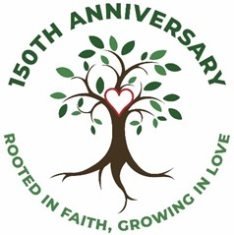
Pastor’s Pen – “Rooted in Faith, Growing in Love”
In case you haven’t heard, our church is celebrating our 150th Anniversary this year! Founded in 1872, First Congregational is one of the oldest churches in Brainerd and our sanctuary is the oldest sanctuary still in use.

As we began to make plans for how we would celebrate this milestone, one of the first tasks we decided to undertake was to come up with a slogan. What would be our guiding statement for our 150th year? With much brainstorming and some find tuning, we landed on the phrase “Rooted in Faith, Growing in Love.” This phrase means a lot to me as your pastor, and I want to share why.

It's important when celebrating this anniversary that we honor and remember the past. But it is equally important that we not allow ourselves to become stuck in a nostalgic mindset. Our history as a community of faith is inspiration that can help inspire and guide us to discern how God might be calling us into our future. This slogan lifts up both of these elements.
Being rooted in faith reminds us and communicates to others that our faith is our foundation. We exist because faithful people sought to worship God and explore their faith together. We’re not a country club with a primary purpose of socializing and recreating. Our Mission is “To share God’s love within us” and it is God’s love calls us into the second half of the slogan.

Growing in Love – This church is one that understands that our God is a God who is still speaking. Our still-speaking God knows that our faith is incomplete if we are only focused on ourselves. We are called to grow our compassion, grow our imagination of what’s possible, grow our hospitality and expansive welcome, as well as to continue to grow our own faith. The logo of the tree reminds us that in the fertile soil of faith, watered with an engaged congregation, and warmed by the Holy Spirit, our church branches will continue to grow.

I am looking forward to all the different celebration events that are planned for this summer. I am excited to see some faces that I haven’t seen since before the pandemic, and I am eager to see how celebrating our 150-year history might inspire us to co-create something new with our steadfast and surprising God.
With God’s love,
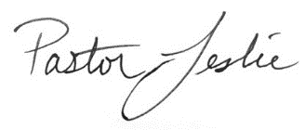

First Congregational UCC News & Updates

How to watch Sunday worship
The worship service is broadcasted on the church Facebook page and the church's YouTube channel every Sunday at 10:00 am.
To watch worship on Facebook, go to https://www.facebook.com/uccbrainerd/live
To watch on YouTube, go to https://www.youtube.com/firstcongregationaluccbrainerd
Live stream videos are saved and can be viewed at any time.
Worship Bulletins are available for download each week at http://tinyurl.com/UCCBrainerdBulletins. The bulletins will be ready for download first thing Sunday morning. They are available in both Word and PDF formats and are labeled by date. You can download the document and print it at home or follow along on your screen.
We can also send a copy of the bulletin in the mail each week as we have been doing for some of our home-bound members. Just contact Terri in the office.
Financial Help Available
Your Church Council voted last year to allow the Pastor's Discretionary Fund to be used to assist church members and others in the Brainerd area who are experiencing financial distress during this time. We received many generous donations! If you need assistance, please email, call, or text Pastor Leslie. Let her know what your situation is and how the church might be of help.
You can now donate to the church online! We are now accepting your offerings and donations using PayPal. You do not need to have a PayPal account to make an online donation with a credit card. To use PayPal, go to: https://www.paypal.me/uccbrainerd

June Birthdays

Eric Lukanen June 2
Patrick Kalinoski June 2
Sarah Jo Armstrong June 5
Linda Tossey June 5
Ryan Kelley June 8
Shelly Trimble June 8
Barb Stokke June 10

Becky Twamley June 10
Lowell Johnson June 20
Dawn Stattine June 22
Patrick Bertram June 23
Claire Steen June 25
Steve Waller June 25
Nancy Gould June 27

Welcome New Church Council Members!

Colleen LeBlanc – Moderator
Tim Anderson – Assistant Moderator
Karen Ford – Clerk
Welcome New Committee Members!
Christian Ministry – Barb Hoeft & Barb McColgan

Church Leadership
Get Involved, Give Back, Grow Connections – Volunteer at Church!

There are many opportunities for you to share your talents:
--Treasurer, serves a 1 year term (may renew for 6 terms). The primary role is oversight of bookkeeping, church finances and Executive Committee discussions. This candidate should have a strong background or interest in finance or banking.

--Council Member-At-Large: Attend council meetings, act as a liaison for church members and council, help with nominations, spokesperson for historically underrepresented groups (HUGS).

Committees needing fresh faces and leadership:
-Christian Education -Trustees -Stewardship -Memorial
-Music -Arts -The Foundation Board -Christian Ministry

Call or text Colleen LeBlanc - Moderator, with your nominations: 218-251-4065

Highlights of Council Meeting, May 19th, 2022 - 7:00 pm (In-person and Zoom)
~ These are highlights. If you would like a copy of the full minutes, please contact the church office ~

Present: Joe Stattine, Colleen LeBlanc, Barb Stokke, Deb Griffith, Lowell Johnson, Alvin Velsvaag, Admin Terri Chidester, Pastor Leslie, Karen Ford (Christian Ministry), and guest Tim Anderson.

Report Highlights:
Clerk: The memorial service for Rev. Dr. David Crum was held May 14 at First Congregational Church, Revs. Leslie Moughty and Linda Crowe officiated.
Pastor: “Thank you to Sue Hadland, Karen Ford, and the Christian Ministry Committee for leading worship on May 1 while I attended the NGLI event in Detroit.” Other report highlights include creating a new Facebook header with the 150th Anniversary logo and creating a Facebook event for the June 19th Organ Concert/Stories in Stained Glass; attending the Next Generation Leadership Initiative in Detroit, April 28-May 2; learning of a homeless coalition with different churches; and starting confirmation classes in June.
Financial: Contributions toward the 150th Anniversary events will be reported in Special Offering, and expenses will be listed under Council expenses. A report will be available each month.
Trustees: Trustees completed a review of the exterior of the parsonage; asked for a revised bid from Dutch’s Electric; have six people who have volunteered to clean the church weekly; are seeking bids for carpet cleaning and window washing; and reported the garden cleaning and hallway painting has gone well. Upcoming projects include painting/staining the parsonage porch deck and steps, the east steps and the church alley steps. They also will be looking at the increase cost of church utilities.
Stewardship: From the Stewardship written report: Stewardship members were happy with the Volunteer Brunch April 24; they have counters for each Sunday; two more Stewardship committee members are needed for 2021-2022; and Stewardship plans to do an Adult Forum in September.
Christian Ministry: From the Christian Ministry written report: CM discussed furnishings for the hallway beneath the stained-glass window and HUGs – the hospitality program that includes Hosts, Ushers, and Greeters.
Christian Education: The adult forum “10 Warning Signs of Alzheimer's Disease” presented by Kent O'Grady from the Alzheimer's Association went well. The next forum will be May 29 with Erica Stepanek, Executive Director of TheShop BBYC (Brainerd Baxter Youth Center).
Members at Large: There has been a good response for having a WISE table at the Picnic and Party in the Park, July 19. The first meeting of Families in Recovery will take place May 28 at Up Front Alano, and work continues on the garden.
Old Business:
- Openings for a treasurer and department and committee members still exist on the slate of candidates for 2022-2023. Council determined that the names of the members of the Pastor Parish Relations Committee should be announced at the Annual Meeting and a description of the work of the committee should be included in the Annual Report.
- Council gave approval for three videos created by Dan Hegstad to be added to the First Congregational Facebook and YouTube pages and shown at the 150th Anniversary events. Moderator Stattine will ask if the WISE/Mental Health aspect can be included in the “Why I Love My Church” video.
- T-Coil Hearing Assistance system, approved and purchased with Foundation monies, is here and ready to be installed.
- If members and friends did not respond to the Connection letter, another attempt to contact them will be made by phone or email to insure we have correct information and to obtain their permission to be included in the church directory.
- Two updated requests to the Memorial Committee have been made by the Council: a request of $3,500 for a sound system in Fellowship Hall, and a request of $3,100 for two large-screen TVs mounted on commercial, mobile stands that could be used on all three floors of the church. It is hoped that the TVs will be available on June 19 for the 150th Anniversary.
- Six people have volunteered to clean the church weekly.
- The Executive committee is researching long- and short-term investment options. They have met with a Thrivent representative and are in contact with United Church Funds.
- Council heard a review of events celebrating the 150th Anniversary taking place June-August.
- Christian Education and Stewardship have submitted their bylaws review, the Trustees review is ready to be sent, and the reviews of Christian Ministry and the Memorial committee are pending.

New Business
- The 150th Annual Election Meeting will be held in person and via ZOOM Sunday, May 22, 2022, immediately after the service.
- The Minnesota Conference UCC Annual Meeting will be held Friday and Saturday, June 10-11, at College of St. Benedict in St. Joseph, Minnesota. Pastor Leslie and Colleen LeBlanc will be attending.

Respectfully submitted, Barbara Stokke, Clerk of Council

Next Regular Council Meeting: June 16, 2022, 4:00 pm in-person & via Zoom
*Note new time

Pride Events June 17th (Youth) and 18th (Picnic)
- Youth Pride Friday June 17th, 2-5pm at the South Lawn of Central Lakes College
Your friendly face is needed to share God’s affirming love with the LGBTQ youth and allies at the first annual Youth Pride Event. You could help with set up, be at the table and talk to the youth about our church, help with clean up, or all of the above. There will be music, food, games, and crafts, and young people from all over central Minnesota.

- Pride Picnic Saturday June 18th from 10am – 4pm at Gregory Park
Share God’s affirming love at this family-friendly picnic. Same opportunities as above. Due to the longer event, more people are needed.
Sign up in the narthex or let Pastor Leslie know if you want to participate!
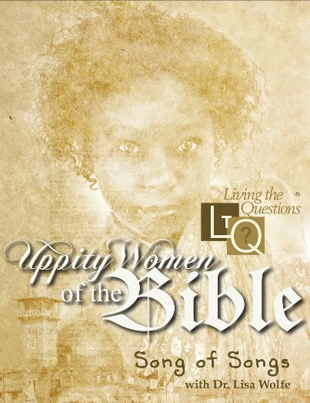
Uppity Women of the Bible Study: Song of Songs
Thursdays at Noon starting June 9th in person and via Zoom.
Join Pastor Leslie for “Uppity Women of the Bible,” a series featuring Hebrew Bible professor Dr. Lisa Wolfe. Combining careful scholarship with humor and fresh insights, Dr. Wolfe presents information for a lively, thoughtful discussion.
Song of Songs is an exquisite collection of love lyrics, arranged to tell a dramatic tale of mutual desire and courtship. It presents an inspired portrayal of ideal human love and a resounding affirmation of the goodness of human sexuality.

Confirmation Classes Begin on June 12 after worship!
Youth entering grades 9th – 12th are invited to explore their faith, ask lots of questions, share their doubts and build community. Text or email Pastor Leslie with to sign up or if you have any questions. At least one parent should attend the beginning of the first session to discuss the schedule.
We are seeking Confirmation Mentors! Walk with one of our confirmands on their journey. You are not expected to have the answers, but to be a partner in their exploration. Let Pastor Leslie know if you are interested. Background check is required.
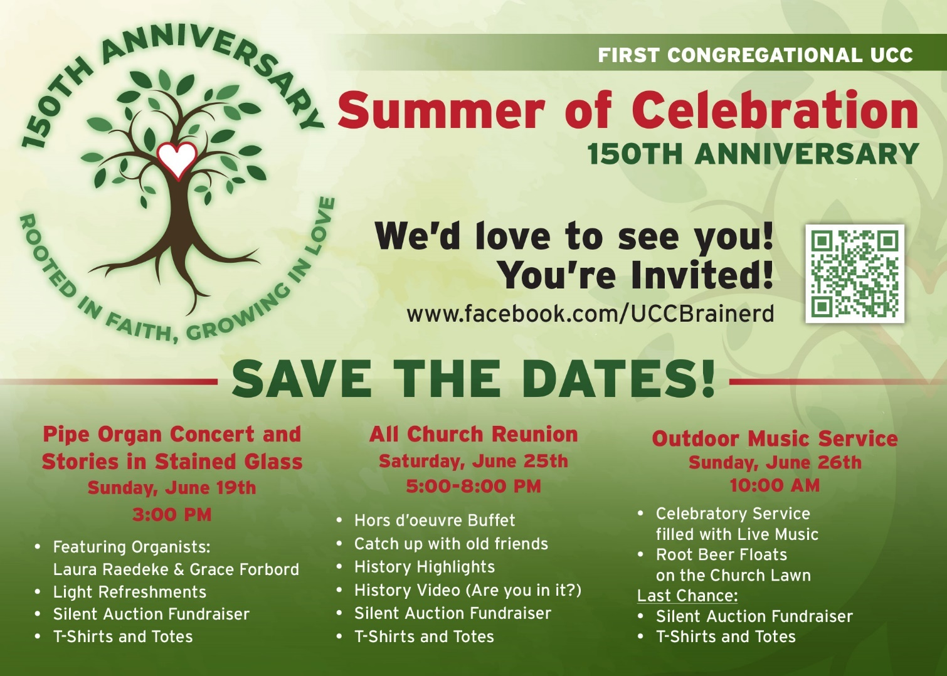

------------------------------------------------------------------------------------------------------------------------------

MORE 150th Celebration Dates - Mark Your Calendars!

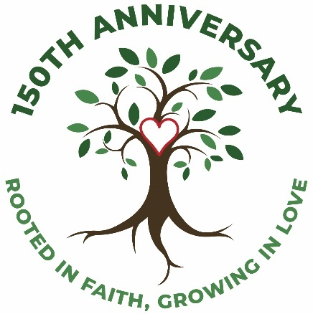
Tuesday, July 19th 5:00 – 7:00 pm
Community Party and Picnic in the Park
A festive, fun-filled afternoon with the surrounding churches, neighbors, and anyone who wants to join us for lawn games,
live music, food, (even some dancing!) and a few surprises!

Sunday, August 14th 10:00 am
Rooted in Faith; Growing in Love, A Celebration Worship Service
We are inviting everyone in town (and out of town
that we know) to join us for this culminating service
of our 150th Anniversary Celebration!
Special Music, Mayoral Proclamation, Imagining the future.
Desserts at Fellowship!
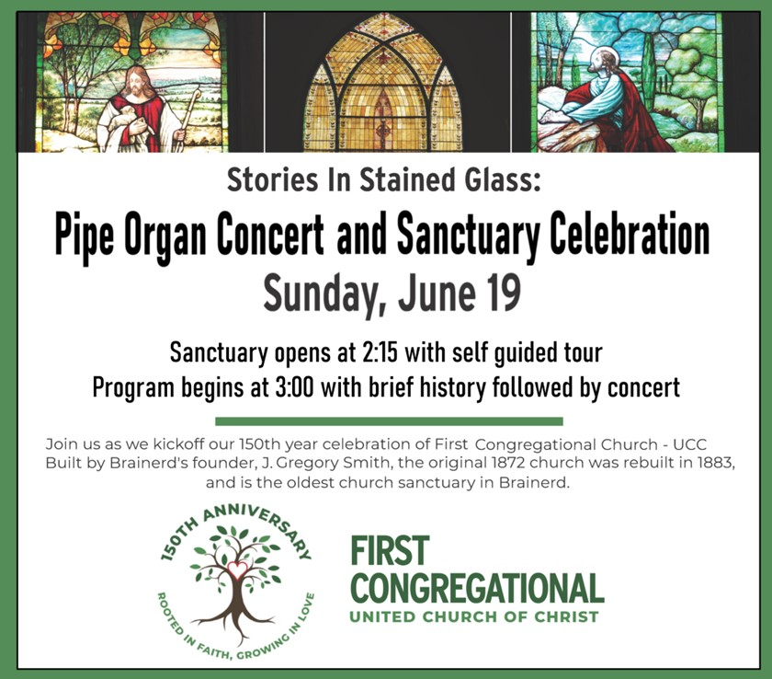
------------------------------------------------------------------------------------------------------------
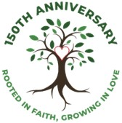
150th Celebration Picnic and Party in the Park - Needs Your Help
As part of our 150th year anniversary celebration, First Congregational is co-sponsoring (with The Shop and Juniper St. churches) a community and neighborhood oriented event on July 19th from 5-7 PM. We plan on serving a free community meal for 200 people, providing lawn games and art activities, and having live music and dancing. Church members are encouraged to come dressed in their church t-shirts or period costumes.
We need lots of help to pull off this event. Starting at 3 PM we will need help with the following needs and tasks.
- 1 more grill and 3 more grillers
- Moving tables and chairs to Gregory Park and back again.
- Servers to help serve the food.
- Runners to transfer food to the serving table.
- 6 more large coolers with ice for water and sodas.
- Numerous lawn games for use by attendees.
- General worker bees to take care of tasks as they arise and help with clean up.
If you can help with any of these tasks, contact Lowell Johnson at 218-820-5290 or johnsonlowells@gmail.com Thank you for your help with this fun community building event!
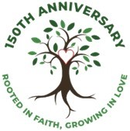

Church Reunion June 25th 5:00pm
Help is needed for the appetizer portion of the Reunion on June 25th
Please contact Karen Ford (651-492-3600) or Jean Schaeffer (218-839-9714) if you are willing and able to help with one or more of the various jobs in advance or on the day of the Reunion.

- Strong people (as many as possible) to take down tables and move chairs Wednesday afternoon, (6/22).
- Cooks (as many as possible) to prepare appetizers in advance of the Reunion. Jean or Karen will provide recipes. (At least 600 total appetizers are needed!)
- Four or more (4+) people needed to assemble food and refill serving trays that evening.
- Four (4) servers for appetizers during the evening.
- Six (6) people to be a part of the clean-up crew.

This will be fun! Thank you for your help!

If you would like to join church members with table reservations
made in advance by Karen Ford,
please contact Karen at:
651-492-3600
Calling all singers and musicians!
We would love to include your voice and/or instruments during the worship services this summer.
Please contact Diane Hauan if interested.
Every Wednesday at Noon
You are invited to a casual fellowship at various locations in the Brainerd Lakes area. Please contact Jack Kraywinkle for location each week.
Jack’s cell” 612-396-3480 or email: kraywinklej@gmail.com

Cooking For Everyone
This group is OPEN FOR EVERYONE!
Email Lowell johnsonlowells@gmail.com and he will add you to the member list so that you will know when and where we will next meet.
TheShop Meal – Wednesday June 15th - 3:45 pm in the church kitchen.
We meet once a month on the third Wednesday.
We are working with the young people from TheShop (Brainerd/Baxter's Youth Empowerment Center) and are preparing a meal and serving it at TheShop for the participants in the program.
Thanks to all who have expressed an interest in helping out. If you are interested in helping,
please call Sharon Carlson at 828-1581.

The Columbarium at First Congregational UCC, Brainerd
The Columbarium is located in the historic space that once was our church’s front entry way. How appropriate it is that our Columbarium now marks another entry way into a new life — where the Spirits of Love and Truth are always present!
Our Columbarium is now complete. Should you wish to learn more about the purchase of a niche for your own cremains or for the ashes of a loved one, please call the church office at (218) 829-2528. Terri Chidester, Administrative Assistant, can send you a packet of materials via email or regular mail. The Memorial Committee has prepared the information packet, and it contains all the details you will need as you consider inurnment here at First Congregational UCC. Have any other questions? Contact Dawn Stattine at dawnstattine@gmail.com

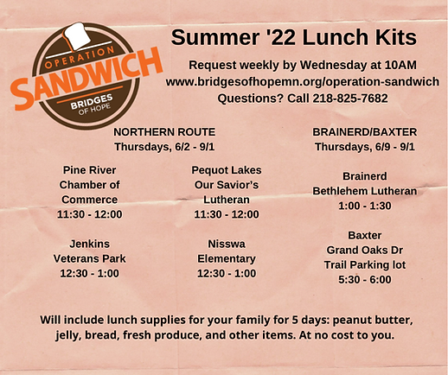
June Special Offering:
Operation Sandwich
Sunday June 26th
Bridges of Hope, through Operation Sandwich, provides much needed meals weekly to students facing summer hunger. Grocery bags including 5 days’ worth of bread, peanut butter, jelly, granola bars, fruit snacks, an additional snack, and fresh fruit and/or vegetables are available for pick-up once per week.
To donate, send a check with "Operation Sandwich" in the memo line to: First Congregational UCC, 415 Juniper St. Brainerd, MN 56401
Or donate online using PayPal and indicate "Operation Sandwich" in the Note. payl.me/uccbrainerd

Church Calendar June 2021
Sunday | Monday | Tuesday | Wednesday | Thursday | Friday | Saturday
 | Office Closed  Open by Appt. | Office Closed  Open by Appt. | Office Hours  10am – 1pm  Pastor Drop-in  2-4pm | Office Hours  10am – 1pm | Office Hours  10am – 1pm  Pastor Drop-in  11am-1pm
 |  |  | 1  9am Foundation Mtg.-Z 10am Prayer Circle- Y  7pm AA Common- Y | 2 | 3  10:30am Book Grp- Y&Z | 4
5  9am Brnrd Frnds-Y  10am Worship & Communion -Y&V  11am Fellowship -Y | 6  7pm BACP-Park w/church backup-Y | 7  2pm Emotions Anon- Y  5:30pm Overeaters Anon- Y | 8  10am Pryr Crcl-Y&Z  7pm Trustees- Y&Z  7pm AA Common-Y | 9  12pm Uppity Women Study-Y&V  5pm LARJP Mtg.  6:30 BLUE - Park/church backup-Y | 10  10:30am Book Grp- Y&Z  UCCMN Annual Mtg | 11  UCCMN Annual Mtg.
12  9am Brnrd Frnds-Y  10am Worship-Y&V  11am Fellowship-Y  11:30 Confirmation-Y | 13 | 14  2pm Emotions Anon- Y  5:30pm Overeaters Anon- Y | 15  10am Pryr Crcl-Y&Z  12pm Memorial-V  7pm AA Common- Y | 16  12pm Uppity Women Study-Y&V  4pm Council Mtg -10am  7pm AA Dist.-Y | 17  10:30am Book Grp- Y&Z  2pm-5pm Youth Pride Event - CLC South Lawn | 18  10am – 4pm Pride Picnic - Gregory Park
19  9am Brnrd Frnds-Y  10am Worship-Y&V  11am Fellowship -Y  11:30 Confirmation-Y  3pm Stories in Stained Glass Pipe Organ Concert | 20  5:30 AAUW – V  Habitat for Humanity Dinner & Auction | 21  2pm Emotions Anon-Y  5:30pm Overeaters Anon-Y | 22  10am Pryr Crcl-Y&Z  7pm AA Common-Y | 23  12pm Uppity Women Study-Y&V | 24  10:30am Book Grp- Y&Z | 25  5pm-8pm 150th Anniv. Church Reunion & Silent Auction
26  9am Brnrd Frnds-Y  10am Worship- Y&V  Special Offering – Operation Sandwich  11am Fellowship -Y  11:30 Confirmation-Y  Newsletter Deadline | 27  2pm AAUW Mtg. | 28  2pm Emotions Anon-Y  5pm Le Mesa- V  5:30pm Overeaters Anon-Y | 29  10am Pryr Crcl-Y&Z | 30  12pm Uppity Women Study-Y&V | *Sunday Book Study on hold  *Choir practice resumes in Sept.  *Girl Scouts #373 resumes in Sept.  *No Memorial Mtg this month | V or Z– Zoom or Specified Online  C – Cancelled  Y – Meeting held  ? – Unknown/no updates

