Friendship News, September 2022
First Congregational United Church of Christ, Brainerd
An Open and Affirming Congregation
Church Office is currently closed due to Covid. Please call to make an appointment.
Office phone 218-829-2528 Office E-mail uccbrainerd@gmail.com Pastor’s E-mail: pastorleslieucc@gmail.com Website: www.uccbrainerdmn.org
Schedule a 1 to 1 (in-person or by Zoom or Phone) with Pastor Leslie:
www.calendly.com/pastorleslieucc/1to1
No matter who you are, or where you are on life’s journey, you are welcome here.
Pastor’s Pen – Pastor Leslie’s Renewal Time
You might be wondering, what will happen at church while I’m gone? A lot of the same stuff that happens while I’m here - engaging worship, committee meetings, group gatherings, pastoral care, adult forums… Here’s what you need to know…
Timeframe: Monday August 22 – Tuesday September 27. (Mondays and Tuesdays are my normal days off)
First Day Back: Wednesday September 28
Who’s leading worship?
August 28 – Rev. Lilja Behr will be preaching and leading worship.
September 4 – Dan Hegstad will lead worship and is offering the message. Grace Forbord will be playing the organ.
September 11 – Hymn Sing! We will be asking for your favorite hymns in creating a worship service around them.
September 18 – Sharing Our Stories: People will be encouraged to write their experiences in church, be it heartfelt or humorous!
September 25 – Joyful Noise service with the Worship Band.
Pastoral Care: If you need pastoral care while I am away, Rev. Lilja Behr and Rev. Rory Swanson (from Park United Methodist) will be available for you. See the schedule and contact information below. You might consider cutting this out and putting it on your fridge or somewhere else visible.
Pastoral Care Schedule
August 22 - September 8: Rev. Lilja Behr at 218-829-0763
September 9 - 20: Rev. Rory Swanson at 218-330-7367
September 21 – 27: Rev. Lilja Behr at 218-829-0763

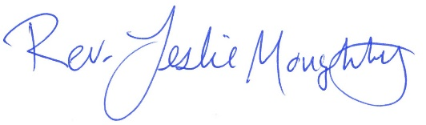
With many blessings,

Moderator’s Musings
When we look at the face of a clock, we see numbers, and perhaps (still) an hour and minute hand and sometimes a second hand moving. What we don’t see are the mechanisms behind the moving parts, nor the person or persons who change the batteries, or wind the clock so it continues to run smoothly. Nor do we think of the folks who actually put these things together in a manner that assures that they work.

When I got home today, I took an extra look at what was printed in the “bulletin” with its announcements, service order, music numbers, etc., and began thinking of all that is required to put just this one thing together each week. My thoughts began to run wild - what about the food prep and service at the fellowship hour, film night, Facebook service broadcast, church upkeep, praying, committee work, WISE activity, SHOP involvement, sharing produce, administrative help, archiving, greeters, readers, ushers, counters and on and on - I was amazed how the list continued to grow. And with each list item, I saw faces. Your faces. In my mind, I looked around the church and I could connect everyone’s face with something they have done and are doing as part of our church life.

I want to thank you - each and every one of you - for what you do for our church family. I want to thank each and every one of you sharing your gifts the way you do. Whether you are part of the “out front” folKs, or the behind-the-scenes persons, you are valued, and appreciated. I am proud to be part of your family. Thank you!

Colleen Leblanc, Council Moderator

First Congregational UCC News & Updates

How to watch Sunday worship The worship service is broadcasted on the church Facebook page and the church's YouTube channel every Sunday at 10:00 am.
To watch worship on Facebook, go to https://www.facebook.com/uccbrainerd/live
To watch on YouTube, go to https://www.youtube.com/firstcongregationaluccbrainerd
Live stream videos are saved and can be viewed at any time.
Worship Bulletins are available for download each week at http://tinyurl.com/UCCBrainerdBulletins.The bulletins will be ready for download first thing Sunday morning. They are available in both Word and PDF formats and are labeled by date. You can download the document and print it at home or follow along on your screen.
We can also send a copy of the bulletin in the mail each week as we have been doing for some of our home-bound members. Just contact Terri in the office.
Financial Help Available Your Church Council voted last year to allow the Pastor's Discretionary Fund to be used to assist church members and others in the Brainerd area who are experiencing financial distress during this time. We received many generous donations! If you need assistance, please email, call, or text Pastor Leslie. Let her know what your situation is and how the church might be of help.
Donate to the church online! We are now accepting your offerings and donations using PayPal. You do not need to have a PayPal account to make an online donation with a credit card. To use PayPal, go to: https://www.paypal.me/uccbrainerd
September Birthdays

Mark Utzinger Sept. 8 Allison Crum Sept. 19
Thomas Nelson Sept. 9 Lynn Fox Sept. 24
Robert Ogdahl Sept. 12 Kaylo Brooks Sept. 25
Joyce Libra Sept. 12 Kyd Lukanen Sept. 27 Lois McBroom Sept. 14 Judy Whiteman Sept. 28 Rod Carlson Sept. 14 Leslie Moughty Sept. 29
Kay Kraywinkle Sept. 15

Church Leadership
Get Involved, Give Back, Grow Connections – Volunteer at Church!

There are many opportunities for you to share your talents!
--Treasurer, serves a 1-year term (may renew for 6 terms). The primary role is oversight of bookkeeping, church finances and Executive Committee discussions. This candidate should have a strong background or interest in finance or banking.

--Council Member-At-Large: Attend council meetings, act as a liaison for church members and council, help with nominations, spokesperson for historically underrepresented groups (HUGS).

Committees needing fresh faces and leadership:
-Christian Education -Trustees -Stewardship -Memorial
-Music -Arts -Christian Ministry

Call or text Colleen LeBlanc - Moderator, with your nominations: 218-251-4065

Highlights of Council Meeting, August 18th, 2022 - 4:00 pm (In-person and Zoom)
~ These are highlights. If you would like a copy of the full minutes, please contact the church office ~

Present: Colleen LeBlanc, Marcia Ferris, Karen Ford, Lowell Johnson, Pastor Leslie Moughty, Marina Gabrowski Absent: Tim Anderson and Deb Griffith Zoom: Administrative Assistant Terri Chidester
July Council Minutes - Approval with no changes. Motion passed unanimously.
Clerk Report – Karen – No activity
Financials
- Internal audit by Joe Stattine and Reed Campbell has not been completed. Final report will be added to agenda for September.
- July financial reports
- Raymond James account closed with check deposited in new Mid Minnesota Federal Credit Union money market account. Karen and Colleen have signed form as signatories. Tim will be the third signatory.
- Questions - None
- Next step to capture some interest on accounts: Table and hold off with decisions for moving $50,000 in checking account to money market account until Leslie is back from her renewal time, and Yvonne Leiser is back from her vacation, to discuss how to go forward. Place on October agenda. Terri will confirm with Yvonne how Terri is to do accounting for the transfer.
- Investment – Talks continue with Thrivent and UC Funds.
- Aitkin UCC check of $2,000, a result of the distribution of asset funds from Aitkin UCC upon closing.

Pastor Report – Rev Leslie – Nothing in addition to her written report.
Member at Large Report – Alvin – In Alvin’s absence, Colleen relayed his report that Danni, the woman working with the WISE garden project, will be a recipient of a Habitat for Humanity home.
Department Reports – anything new to add to written reports?
- Trustees – Deb – Reported that Trustees will meet before end of August to review procedures for building and property care and use as suggested by Council.
Stewardship – Marcia – On Church Service days, two people from Trustees and/or Stewardship are often not available for counting the service offerings, as our bylaws indicate is necessary. Because not enough people are always available, discussion was if it is possible to change the requirement to be at least one person from either the Trustees or Stewardship committees be a counter and that the second person could be another person who will have received the necessary counting training. The motion was unanimously approved. A training video, made by Marcia and Terri, is available for counters’ training purposes.
- Plans for Stewardship kickoff will be discussed at a meeting on 9/2/2022.
- Christian Ministry – Marina – Department is working on by-laws.
- Christian Education – Lowell – Request for approval of film license purchase. $265 fee for film license be paid. Motion unanimously approved. A date will be set for the first evening meeting of the Film Group.
Lowell announced that the following Sunday morning forums are: 9/11 - 100 Conversations; 9/18 - Death Café; 9/25 - Stewardship Kickoff Information; and 10/2 - Swedish Death Cleaning.
Old Business
- Kid Zone (pray ground) and worship activity bags/intergenerational activities w Park UMC. Marina volunteered to make new activity bags. A rug has been donated by Whiteman’s.
- 150th Anniversary Celebration – Rev Leslie/Lowell – Reimbursement forms and invoices must be turned in to complete the accounting process. Currently, $6,825 in revenue and $3,985.93 in expenses have been accounted for, with a $2,839.07 in profit made from the anniversary sales and donations.
New Business
- Proclamation - Recognizing the Second Monday of October as Indigenous American Peoples’/Treaty Day (See attached) –Lowell requested the Council’s support for the Brainerd mayor to make the proclamation. Motion to write a letter to the Mayor of Brainerd to show our support. Motion unanimously approved. Colleen will write and send the letter.
- Facility use policy/wedding guidelines, fees update - Add to September agenda. Colleen will check with Deb if it appropriate for Trustees to address updating these policies for Council.
- “Manual on Church” webinar. Colleen asked Council members to watch this youtube video for ideas for visioning the future of our church. https://youtu.be/OsNdRYFIHig

Next Regular Council Meeting: September 15th, 2022, 4:00 pm in-person & via Zoom

Hosts, Ushers, Greeters, Scripture-readers
Sunday morning greeters/ushers and coffee hosts play an important part in making our church a warm and welcoming place for all. Here’s a secret; it’s FUN!! If each household committed to 3 Sundays a year as greeter/ushers and/or coffee hosts we would have a full complement of participants. For instance, I plan to take 2 Sundays in August to greet/usher and 2 Sundays in February to Host Coffee.
The Christian Ministry Committee is working on simplified instructions for these duties and one of us will be available to guide you through your first go if needed. Are you ready to take the leap into RADICAL HOSPITALITY? Give it a go and signup below for your first Sunday as the face of the church! https://www.signupgenius.com/go/10C0E48A9A823A5FFC07-hugs/16034811
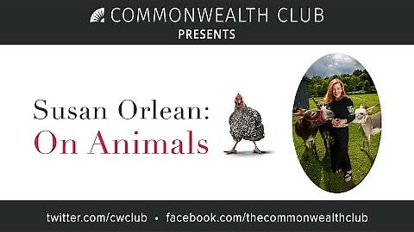
Friday Book Group - 10:00 am
Via Zoom: tinyurl.com/uccbrainerdzoom
We are reading "Susan Orlean, On Animals" (about the interaction between animals and humans). Warm and Witty collection of essays.

Meets at Noon each Wednesday of the month

Weekly rotating Schedule
1st Wednesday: B-Merri - 19624 Co. Rd. 3 Brainerd
2nd Wednesday: Yesterday's Gone Bar & Grill - 219 So. 9th St. Brainerd
3rd Wednesday: Dunmire's on the Lakes - 19090 MN 371 Brainerd
4th Wednesday: Dennis Drummond Wine Co. - 11919 Thiesse Rd. Brainerd
5th Wednesday: El Tequila Mexican Restaurant - 7399 Garrison Rd. Baxter

UCC TheShop Meal Effort Needs Volunteers!

Unless we get more volunteers, our last meal will be Wednesday, September 21st at 3:45 pm.

For the last several years, UCC volunteers have provided a meal to the youth at TheShop - Brainerd Baxter Youth Drop-in Center. On the third Wednesday of the month, 3-4 youth from TheShop come over to our kitchen and help prepare a delicious meal that is then brought back to TheShop for the hungry and appreciative teens there.
If you are interested about joining this effort, contact Sharon Carlson 218-828-1581or Lowell Johnson 218-820-5290 or johnsonlowells@gmail.com

September/October Adult Forum
11:30 after worship

September 11th: 100 Conversations Report -The 100 Community Conversations project that many of our members took part in as interviewers or interviewees, has issued its report. Join us for a discussion of the results and idea sharing for developing a Community Resilience Plan.
September 18th: Death Café - A Death Cafe is a group directed discussion of death with no agenda, objectives, or themes. It is a discussion group rather than a grief support or counseling session. The Death Cafe model was developed by Jon Underwood and Sue Barsky Reid of London, England, based on the ideas of Bernard Crettaz. They have spread in popularity around Europe and the United States and are now taking place in over 81 counties. Please join Ellie Burkett on September 18th in a safe space to talk about death and dying, sharing ideas and listening to make the most of our finite lives.
September 25th: Fall Stewardship Kick-off – Join the Stewardship committee after worship and learn how you can help the 2023 pledge drive be more successful. We will have handouts explaining the process and we will answer questions. We will also talk about leaving a Legacy, which has been so important to the financial viability of this church. Stewardship includes your financial contributions and the gift of your time and talents to keep this church healthy.

Do you have ideas for topics or connections with people who might be willing to lead Adult Forums? If so contact Lowell Johnson at 218-820-5290 or johnsonlowells@gmail.com
Let's see if they can be organized and scheduled.

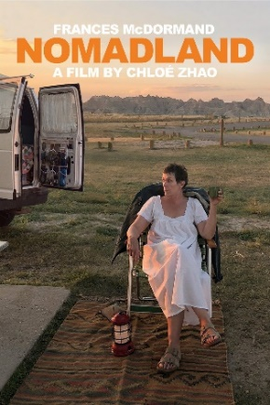
Movie Night is starting up again this month!
Mark your Calendars!
Friday, September 23rd at 6:00 - 9:00 pm
Fellowship Hall In-person
Movie "Nomadland"
The remarkable odyssey of a feisty woman who finds community
and her true self in her home on the road.

Choir Update! Mark Your Calendar!
Our first rehearsal will be November 20th at 8:30 am.
Choir is going to look a little different this year.
We are going to sing for two seasons, the advent season and the lent season. We will of course sing for Christmas and Easter.
We would like to invite anyone that would like to sing during those seasons to join us. Or you can just choose one or the other and join us for that. Sometimes things get very busy and you don’t have an entire year to commit. I’d like to see you with us for any time that you can send your heavenly voices out to the congregation.
If you have any questions you can text or call Diane Hauan at 218–839–0669.

Special Offering - Sunday September 25th
UCC Missions - Neighbors In Need
Neighbors in Need (NIN) is a special mission offering of the United Church of Christ that supports ministries of justice and compassion in the United States. In 2022, the Neighbors in Need “BEHOLD!” offering focuses on an economic justice.
To donate, send a check with "NIN" in the memo line to: First Congregational UCC, 415 Juniper St. Brainerd, MN 56401 or donate online using PayPal and indicate "NIN" in the Note. payl.me/uccbrainerd

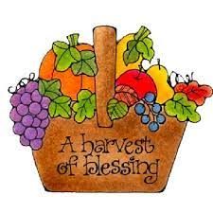
Garden Gleaning Offerings
Gardeners and plant people bring to the church your “gleanings” to share. This ranges from rhubarb in the spring to daffodil bulbs in the fall. A table, poster and donation basket are in Narthex entrance. Enjoy the fruits of our labors! All are welcome to help themselves – no charge! All monetary donations are given to the Food Shelf. Using our resources, recycling, re-purposing, and not wasting our food are all acts of Creation Care and Justice. Garden Gleaning is an Easy-Peasy way to put words into action.

The Columbarium at First Congregational UCC, Brainerd
The Columbarium is located in the historic space that once was our church’s front entry way. How appropriate it is that our Columbarium now marks another entry way into a new life — where the Spirits of Love and Truth are always present! Should you wish to learn more about the purchase of a niche for your own cremains or for the ashes of a loved one, please call the church office at (218) 829-2528. Terri Chidester, Admin. Asst., can send you a packet of materials via email or regular mail. The Memorial Committee has prepared the information packet, and it contains all the details you will need as you consider inurnment here at First Congregational UCC. Have any other questions? Contact Dawn Stattine at dawnstattine@gmail.com

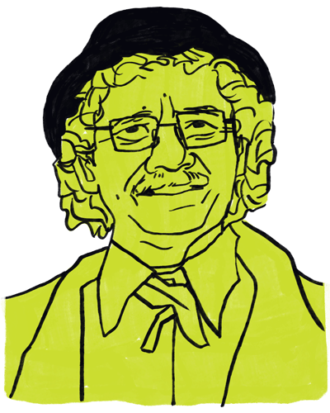
Congratulations Lowell!
Lowell was nominated for this AARP annual event and named
a 50 over (age) 50 winner. Check it out! Look under Community category.
https://www.pollenmidwest.org/stories/2022-50-over-50/

Kinship Partners Offering Free Training
Tuesday, September 6th at 2:00 pm Kinship Partners will be offering free training on the Adverse Childhood Experiences (ACEs) and NEAR Science. Pre-register to amyg@kinshippartners.org by September 2nd.
NEAR stands for Neuroscience, Epigenetics, Adversity (the ACE study) and Resilience. This workshop will be held at St. Paul's Episcopal Church. It is open to the public and free.

Are You Called to the Jail?

Over the last 10 years or so, A number of UCC and other community folks have been volunteering in the Crow Wing County Jail. Covid shut down this programming. There is an effort now to bring back valuable programming to the residents of the jail. If you have any interest in this effort, contact Lowell Johnson 218-820-5290 for more information on the wide range of volunteer opportunities there.

BUILDING HOPE GALA
Join us as we celebrate 20 years of Building Bridges at our first ever semi-formal event on Saturday, September 24th at Grand View Lodge’s Gull Lake Center. The evening will include a social hour, dinner, program, auction, and live music & dancing! We are excited to reminisce over the past 20 years and look forward to the future with all who make it possible for us to build bridges in our community. Individual seats, tables for 10, and table sponsorships are available. Would you like to contribute an item to our auction?
Contact nicholle@bridgesofhopemn.org.
Buy Tickets

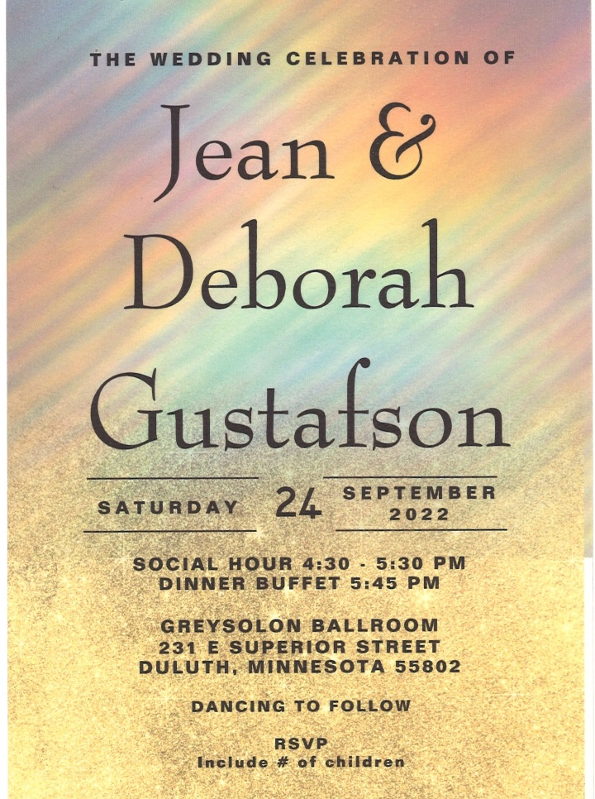
Gustafson Wedding Celebration!
Saturday September 24th, 2022
First Congregational church members and friends are cordially Invited.

Please RSVP to:
Jean Gustafson
102 Laurel Street
Brainerd, MN 56401

Save these Dates!

The Rally for Peace
Saturday, October 1, 2022

Leif Erickson Park
11th Ave E & London Road, Duluth MN

First Congregational’s 150th Celebration Committee announces a major event, sponsored by Peace, as a gift to our community to celebrate our 150th Anniversary. Keynote speaker David Hogg a survivor of the Marjorie Stoneman Douglas High shooting. Hogg is a co-founder of March for Our Lives. We are looking for volunteers and to include other churches to partner with us. Contact Marsha Hystead (Duluth) at mhystead@haileysault.com or 218-343-0118
--------------------------------------------------------------------------------------------
Out of the Darkness Nisswa Walk
Saturday, October 15th, 2022

The Pines at Grand View Lodge
23521 Nokomis Ave. Nisswa, MN 56468

Register at
Afsp.org/Nisswa

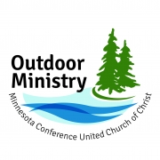

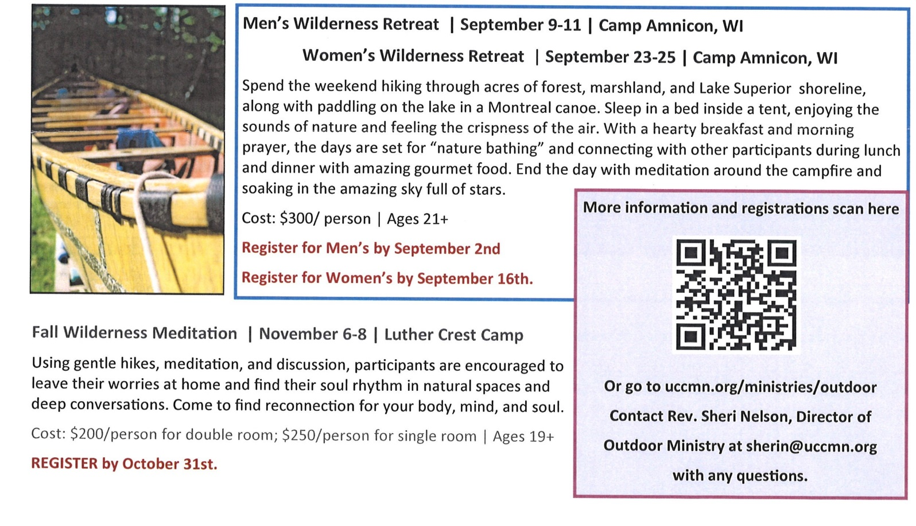
Registration is Open!

Church Calendar September 2021
Sunday | Monday | Tuesday | Wednesday | Thursday | Friday | Saturday
 | Office Closed  Open by Appt. | Office Closed  Open by Appt. | Office Hours  10am – 1pm  Pastor Drop-in 2-4pm | Office Hours  10am – 1pm | Office Hours  10am – 1pm  Pastor Drop-in  11am-1pm
V or Z– Zoom or Virtual Online  C – Cancelled  Y – Meeting held  ? – No updates | No Communion this month |  |  | 1  6:30 BLUE-Park/church backup-Y | 2  10:30am Bk Grp- Z  3pm Stewardship Mtg.-Y | 3
9am Brnrd Frnds-Y 4  10am Worship-Y&V  Dan Hegstad sermon  11am Fellowship -Y  11:30 Adult Forum-Y | 5  7pm BACP-Park w/chrch backup-Y | 6  2pm Emotions Anon- Y  5:30pm Overeaters Anon-Y | 7  10am Pryr Crcl-Y&Z  12pm Mens Grp  @ B-Merri-Y  7pm AA Common-Y | 8  5-8pm LARJP in Fellowship Hall | 9  10:30am Bk Grp- Z | 10
9am Brnrd Frnds-Y 11  10am Hymn Sing Worship-Y&V  11am Fellowship  11:30 Adult Forum-Y | 12 | 13  2pm Emotions Anon- Y  5:30pm Overeaters | 14 10am Pryr Crcl-Y&Z  12pm Mens Grp-@ Yesterday’s Gone-Y  7pm AA Common- Y | 15  4pm Council Mtg –  7pm AA Dist.-Y | 16  10:30am Bk Grp- Z | 17
9am Brnrd Frnds-Y 18  10am Sharing our Stories Worship-Y&V  11am Fellowship -Y  11:30 Adult Forum-Y | 19 | 20  2pm Emotions Anon-Y  5:30pm Overeaters Anon-Y | 21  8:30am Fndatn Mtg.-Z  10am Pryr Crcl-Y&Z 12pm Mens Grp @Dunmire’s North-Y  7pm AA Common-Y | 22 | 23  10:30am Bk Grp- Z  6-9pm Movie Night-Y  In Fellowship Hall | 24
9am Brnrd Frnds-Y 25  10am Worship w/The Worship Band- Y&V  Special Offering  Neighbors in Need  11am Fellowship -Y  11:30 Adult Forum-Y Newsletter Deadline | 26  . | 27  2pm Emotions Anon-Y  5pm Le Mesa- Park/ church backup- Y  5:30pm Overeaters Anon-Y | 28  10am Pryr Crcl-Y&Z 12pm Mens Grp @ Dennis Drummond Wine Co.-Y  7pm AA Common-Y  Pastor Leslie back from Renewal | 29 | . 30  10:30am Bk Grp- Z | *Sun. Bk Stdy on hold  *Choir practice resumes in Nov.  *Girl Scouts #373 resumes-?

