Friendship News, August 2022
First Congregational United Church of Christ, Brainerd
An Open and Affirming Congregation
Church Office is currently closed due to Covid. Please call to make an appointment.
Office phone 218-829-2528 Office E-mail uccbrainerd@gmail.com Pastor’s E-mail: pastorleslieucc@gmail.com Website: www.uccbrainerdmn.org
Schedule a 1 to 1 (in-person or by Zoom or Phone) with Pastor Leslie:
www.calendly.com/pastorleslieucc/1to1
No matter who you are, or where you are on life’s journey, you are welcome here.

Pastor’s Pen – Sabbath and Renewal
For this month’s Pastor’s Pen, I considered writing about the upcoming 150th Anniversary Celebration Worship Service. (It’s on your calendars, right? August 14 at 10:00 am!) I am really looking forward to celebrating this incredible milestone with all of you. This church has a lot to celebrate and a lot to look forward to and you are an important part of that future! So, I do hope you will come and stay for delicious desserts and fellowship after the service.
But as I got ready to write, I felt a nudge to focus on something else. Sometimes I feel confident that a “nudge” is an invitation from the Holy Spirit. Sometimes I’m not sure. This feels like a Holy Spirit nudge and so I hope this message is received by whoever needs to read it. It’s ok to rest and take care of yourself. Not only is it ok; it’s necessary and important.
Some of you know I have been challenged with quite a few health issues this year. None of them have been crises, but what they have done is call into focus the importance of self-care. A few of the issues I deal with, including my newly diagnosed diabetes, improve with stress-reduction, getting enough sleep, and consistent exercise. That’s quite the motivation for self-care! But life gets busy, and there’s only 24 hours in a day, so I often struggle to do the things that support my wellness. I bet some of you can relate.
Tending to our mental, emotional, and spiritual health can also be challenging. Especially when there is so much that feels wrong with the world. According to a recent article published by the World Health Organization, the Covid-19 pandemic led to a 25% increase in the prevalence of depression and anxiety worldwide. A March 2022 poll conducted by the American Psychological Association revealed that the pandemic along with the war in Ukraine, financial stresses, and a myriad of other concerns have pushed stress levels in adults in the US to alarming levels.
If you are feeling anxious or depressed or frazzled or irritable, or apathetic… these are all normal and reasonable responses to what is going on around us. It is as important as ever to notice how we are feeling, how our bodies are responding, and how our spirits feel, and take steps to support our physical, mental, and spiritual health. There are a lot of different ways to do that and what is helpful for one person may not be helpful for another. I invite you to explore what works for you. I have a few suggestions from a faith perspective, but I also encourage you to connect with a medical doctor and/or a mental health provider.
Coming to church can be an important part of renewing our spirits. It allows us to create and deepen connections with other people, set aside time to focus on God and our faith life, and reflect on what is most important in this wild and precious time we call life.
Serving others can help us destress when the source of that stress is a feeling of helplessness. So much of what is hard and scary in the world right now is out of our control. But we can control whether or not we help someone else feel less lonely, less hungry, or more welcome and affirmed. Not to mention it’s part of our identity as people who follow the teachings of Jesus.
Sabbath is a concept that we seem to give lip service to in this country. It is the biblical commandment from God to rest. We are called to completely refrain from work and focus our attention on God, on the gifts of life, on what really matters most. It serves to keep us from turning work and busyness into an idol, and it keeps us from falling apart. Our brains, our bodies, our spirits need that time to heal, to recenter, to tend to meaningful relationships – including the one we have with ourselves and the one we have with the Source of Life. This concept is frankly quite countercultural. We live in a society that often seeks to define our value by our productivity.
God values each of us for who we are, not what we produce. We are beloved because God’s love is unconditional. My hope for all of us is that we might love ourselves, and care for ourselves and each other, knowing that God desires for us to live lives of balance and wholeness.

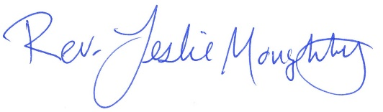
With many blessings,

Pastor Leslie’s Renewal Time
It’s amazing how time flies! My first day as Pastor of First Congregational was February 12, 2015. It’s hard to believe it’s been 7-1/2 years! Some of you may know that I was eligible for a sabbatical after 5 years of service which was February 2020. Due to a number of factors, including the Covid pandemic, I have not been able to take this much needed time for renewal. After discussing multiple options and consulting with the Minnesota Conference, the church council graciously granted me with 4 weeks of renewal time.
In partnership with the Pastor Parish Relations Committee, the council agreed that adding these 4 weeks to one week of Continuing Education funded by the Next Generation Leadership Initiative. Including her regular days off of Monday and Tuesday, I will be “out of the office” beginning August 22nd through September 27th. Then I begin renewal leave on August 31st through September 28th. We will begin planning for a full sabbatical will begin after I return, including an application for a Lily Foundation Grant due in April 2023, with the sabbatical expected to take place in 2024.
You might be wondering, what will happen at church while I’m gone? A lot of the same stuff that happens while I’m here - engaging worship, committee meetings, group gatherings, pastoral care, adult forums… Here’s what you need to know…
Timeframe: Monday August 22 – Tuesday September 27. (Mondays and Tuesdays are my normal days off)
First Day Back: Wednesday September 28
Who’s leading worship?
August 28 – Rev. Lilja Behr will be preaching and leading worship.
September 4 – Dan Hegstad is offering the message and Grace Forbord will be playing the organ.
September 11 – (tentative) Hymn Sing! We will be asking for your favorite hymns in the next few weeks and creating a worship service around them.
September 18 - (tentative) Jan Kurtz will be giving a message
September 25 – Joyful Noise service with the First Congregational Band (they need a name, any ideas?)
Pastoral Care: If you need pastoral care while I am away, Rev. Lilja Behr and Rev. Rory Swanson (from Park United Methodist) will be available for you. See the schedule and contact information below. You might consider cutting this out and putting it on your fridge or somewhere else visible.
Pastoral Care Schedule
August 22 - September 8: Rev. Lilja Behr at 218-829-0763
September 9 - 20: Rev. Rory Swanson at 218-330-7367
September 21 – 27: Rev. Lilja Behr at 218-829-0763

Moderator’s Musings
Wow! What an incredible Party and Picnic in the Park! The photos I took are testimony of how our church family and neighborhood worked together to put on a very successful celebration.

I have pictures of canapés almost flying off in the wind; and someone creatively using a tire iron as a tent stake to hold the canapé in place; young people assembling and playing games together; folks blowing up ice tubs to keep the potato salad cold; food being prepared and served with so many smiles; people constructing and “manning” information tables; putting together all of the electronics so participants could enjoy the music and dancing, pickup trucks transporting tables and chairs. It was a whirl of activity under a beautiful blue sky.

After the food was served and program presented, everyone pitched in to clean up and leave the park as we had found it. Memories remain, perhaps a few new friendships were made or renewed, and good feelings, I believe, were had by all.

A comment I heard from a passerby: “This is how it should be-love all around!” Thank you to everyone who worked so hard to bring our church family and neighborhood together to spread love all around as we celebrated FCUCC Brainerd’s 150th Anniversary.

Colleen Leblanc, Council Moderator

First Congregational UCC News & Updates

How to watch Sunday worship The worship service is broadcasted on the church Facebook page and the church's YouTube channel every Sunday at 10:00 am.
To watch worship on Facebook, go to https://www.facebook.com/uccbrainerd/live
To watch on YouTube, go to https://www.youtube.com/firstcongregationaluccbrainerd
Live stream videos are saved and can be viewed at any time.
Worship Bulletins are available for download each week at http://tinyurl.com/UCCBrainerdBulletins.The bulletins will be ready for download first thing Sunday morning. They are available in both Word and PDF formats and are labeled by date. You can download the document and print it at home or follow along on your screen.
We can also send a copy of the bulletin in the mail each week as we have been doing for some of our home-bound members. Just contact Terri in the office.
Financial Help Available Your Church Council voted last year to allow the Pastor's Discretionary Fund to be used to assist church members and others in the Brainerd area who are experiencing financial distress during this time. We received many generous donations! If you need assistance, please email, call, or text Pastor Leslie. Let her know what your situation is and how the church might be of help.
Donate to the church online! We are now accepting your offerings and donations using PayPal. You do not need to have a PayPal account to make an online donation with a credit card. To use PayPal, go to: https://www.paypal.me/uccbrainerd

August Birthdays – HAPPY BIRTHDAY!

Nicole Grabowski August 2
Diane Hauan August 8
Bodie Brooks August 10
Jack Olson August 10
Brian Twamley August 12
Shirley Barten August 13
Joseph Stattine August 13
Addison Ferrie August 15
Emma Widmark August 16
Jill Carlson August 17
Maria Bertram August 21
Cameo Ellis August 22
Jeanne Schaeffer August 23
Terry Boman August 27
Dana Watson August 27
Arlene Jones August 28
Samuel Stadem August 30

Church Leadership
Get Involved, Give Back, Grow Connections – Volunteer at Church!

There are many opportunities for you to share your talents:
--Treasurer, serves a 1-year term (may renew for 6 terms). The primary role is oversight of bookkeeping, church finances and Executive Committee discussions. This candidate should have a strong background or interest in finance or banking.

--Council Member-At-Large: Attend council meetings, act as a liaison for church members and council, help with nominations, spokesperson for historically underrepresented groups (HUGS).

Committees needing fresh faces and leadership:
-Christian Education -Trustees -Stewardship -Memorial
-Music -Arts -Christian Ministry

Call or text Colleen LeBlanc - Moderator, with your nominations: 218-251-4065

The First Congregational UCC’s Foundation looking for a new Board Member

It is a great job – only 4 meetings a year, usually via Zoom. The Board receives requests for funding, evaluates requests and either accepts or rejects requests based upon the by-laws of the Board and the dollar amount requested. The Board may request more information before a decision is made to accept or reject. The best part of being on the Board is that its members get to spend money!
If you are interested or would like more information, contact Lisa Wigand, Board Chair,
at (218)330-8477 or lisawdavet@outlook.com

Highlights of Council Meeting, July 21st, 2022 - 4:00 pm (In-person and Zoom)
~ These are highlights. If you would like a copy of the full minutes, please contact the church office ~

Present Tim Anderson, Marina Grabowski, Deb Griffith (via Zoom), Lowell Johnson, Colleen LeBlanc, Pastor Leslie Moughty, Alvin Velsvaag, Judy Whiteman
Absent: Terri Chidester, Karen Ford
Financial Report
- At this time, giving units are behind last year. Possible reasons: ,smaller attendance in worship
- Colleen mentioned Joe Stattine and Reed Campbell have agreed to perform a half year internal audit of January – June financials - “2nd pair of eyes” after the work of Terri and Yvonne Leiser. Joe and Reed will check-in with Pastor Leslie or Yvonne Leiser with any questions and provide a written report for August Council review.
- Judy asked about silent auction proceeds. Pastor Leslie’s approximate total sales count through July 8th is $6,603 including t-shirts.
- Colleen brought up more income possibilities by renting time/space in church property. Tim will research non-profit laws/regulations concerning use.

Investments: Approximate balances:
Checking account balance: $130,000
CD: $8,000
Raymond James account: $35,000
- The executive committee and the Raymond James account advisor have advised closing the Raymond James account. Church is not earning interest on the account balance and pays an annual fee to maintain the account. Two alternative banks were discussed - Bremer Bank and Mid MN Credit Union. Colleen explained the different bank interest earning rates and bank fees. It was determined Mid MN has better interest earning rates and fewer fees.
- A motion was made by Lowell Johnson and 2nd by Deb Griffith to close the Raymond James account. Motion approved by all attendees.
- A motion was made by Alvin Velsvaag and 2nd by Marina Grabowski to open a money market account at Mid MN Credit Union and deposit the money from the Raymond James account into the money market account. Motion approved by all attendees.
- Before cash balance is transferred from Raymond James, Colleen will contact Mid MN Credit Union to set up a money market account and coordinate account signatures needed. When the account has been set up, Raymond James will send a check to the church address. The check will be deposited in the new money market account. Note: The Mid MN Credit Union account will be a temporary holding account for the $35,000 + until a decision is made to best invest the account balance. Two places being considered are UC Funds and Thrivent Financial.
Department Reports
Trustees – Deb
Did not meet in July. Parking lot door not opening properly. Deb will contact installer to come look at the door installed 2 years ago.
Stewardship – Judy
Did not meet in July. Department has 4 members. Need extra hands.
Christian Ministry – Marina
No additions to written report.
Christian Education- Lowell
- Adult forum starts in the fall. Working with Marcia Ferris for forum dates for Stewardship committee.
- Film group comeback!
- Mental Health – depression/anxiety topics
Members At Large – Alvin
- Signs outside the church are awesome!
- WISE table at picnic was a success. Many conversations with neighbors and folks seeking a church and youth programs discussed.
- Men’s Group – Had a field trip to Hunt Technologies – “Turtle” invention – reading meter. Founder Paul Hunt interested in sustainable food practices, etc. Environmental group forum topic?
Pastor
- Pastor Leslie mentioned she is looking for mentors for two confirmands.
- In-person worship attendance low. Families with children/youth in particular are slow to return. Pastor Leslie has heard other churches experiencing the same issue. Ideas to youth:
- Make nursery more youth inviting, transform into “kids’ room”. Thanked Sharon Carlson for recent work on the nursery.
- Enhance worship bags – quiet toys, coloring pages, etc.
- Create “Prayground” for kids in the sanctuary.
- Intergenerational activities.
- Schedule kid events.
- Pastor Leslie brought up upcoming out of office time in September. Lija B. and Rory S. have agreed to cover pastoral care. Lilja B. Dan H., Jan K. and others will lead worship.

Old Business
- Reminder to update church directory with changes from Terri’s emails.
- 150th Anniversary update from Lowell: total expenses = $1131
- Between 100 – 200 people attended
- Big thank you to all the church members who helped with windblown canopies, food service and everything else. Very much appreciated!
- Pastor Leslie had sent out post cards to neighborhood homes.
- It was reported that with the silent auction and other sales items, the 150th celebration is currently, somewhat profitable – at the least, costs have been covered.
- Judy asked about printing costs and other costs. A full August financial report will be available for the September Council meeting.
- August 150th celebration service and reception costs remain to be added to total cost.

New Business
- Rally for peace in Duluth happening in October: Mike North sent information to Colleen who will get it to Terri.
- What is the process to communicate/include events in bulletin? Give to Terri. If Terri questions the information, she will ask Pastor Leslie if it is appropriate to include in the newsletters.
- Judy noted that she would like to get church news to newspapers more than every other week.
- StrikePoint HandBell Ensemble from Duluth event was attended by approx. 50-60 people.

Next Regular Council Meeting: August 18th, 2022, 4:00 pm in-person & via Zoom

Hosts, Ushers, Greeters, Scripture-readers
Sunday morning greeters/ushers and coffee hosts play an important part in making our church a warm and welcoming place for all. Here’s a secret; it’s FUN!! If each household committed to 3 Sundays a year as greeter/ushers and/or coffee hosts we would have a full complement of participants. For instance, I plan to take 2 Sundays in August to greet/usher and 2 Sundays in February to Host Coffee.
The Christian Ministry Committee is working on simplified instructions for these duties and one of us will be available to guide you through your first go if needed. Are you ready to take the leap into RADICAL HOSPITALITY? Give it a go and signup below for your first Sunday as the face of the church! https://www.signupgenius.com/go/10C0E48A9A823A5FFC07-hugs/16034811

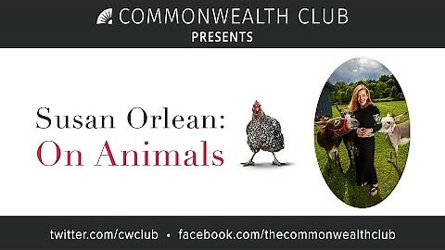
Friday Book Group - 10:00 am via Zoom
We are reading "Susan Orlean, On Animals" (about the interaction between animals and humans). Warm and Witty collection of essays.

Confirmation Classes after worship August 7th & 21st
We are seeking Confirmation Mentors! Walk with one of our confirmands on their journey. You are not expected to have the answers, but to be a partner in their exploration. Let Pastor Leslie know if you are interested. Background check is required.

Calling all singers and musicians!
We would love to include your voice and/or instruments during the worship services this summer.
Please contact Diane Hauan if interested.

Every Wednesday
You are invited to a casual fellowship at various locations in the Brainerd Lakes area.
For more information contact Jack Kraywinkle
or the church office: 218-829-2528

Cooking For Everyone
This group is OPEN FOR EVERYONE!
Email Lowell johnsonlowells@gmail.com and he will add you to the member list so that you will know when and where we will next meet.

Our 150th Anniversary
Final Event!
Culminating Worship Service for our
150th Anniversary Celebration!
Sunday, August 14th 10:00 am
Rooted in Faith;
Growing in Love Service of Celebration
Special Music, Guest Preacher Rev. Kevin Brown Envisioning our Future
& Delicious Desserts!

----------------------------------------------------------------------------------------------------------------------------

150th Anniversary – Collecting Memories
August 7th | 2020 W.I.S.E. - 100 Conversations was initiated locally by the ACEs Resiliency Coalition and the Mental Fitness Goal Group of Crow Wing Energized.  By having 1:1 conversations with people defined as marginalized, such as those living with experiences of addiction, homelessness, mental illness, disability, incarceration, people of color, LGBTQ+. . . would have more representation in policy making to better serve their needs. | Would you like to join the conversation?  Contact: Pat Scott or  Alvin Velsvaag
August 14th | Making History! Today is the Day

Special Offering - Sunday August 28th
TheShop (Brainerd Baxter Youth Center)
The Brainerd Baxter Youth Center (TheShop) is a non-profit organization committed to providing community support to all teenagers and young adults as they transition into independence and adulthood. We are a safe space where youthful energy is harnessed into creative energy by providing opportunities to explore potential, building lasting relationships, and establish personal connections.
http://www.facebook.com/TheShopBBYC
http://www.theshopbrainerd.org/
To donate, send a check with "TheShop" in the memo line to: First Congregational UCC, 415 Juniper St. Brainerd, MN 56401 or donate online using PayPal and indicate "TheShop" in the Note. payl.me/uccbrainerd

The Columbarium at First Congregational UCC, Brainerd
The Columbarium is located in the historic space that once was our church’s front entry way. How appropriate it is that our Columbarium now marks another entry way into a new life — where the Spirits of Love and Truth are always present!
Our Columbarium is now complete. Should you wish to learn more about the purchase of a niche for your own cremains or for the ashes of a loved one, please call the church office at (218) 829-2528. Terri Chidester, Administrative Assistant, can send you a packet of materials via email or regular mail. The Memorial Committee has prepared the information packet, and it contains all the details you will need as you consider inurnment here at First Congregational UCC. Have any other questions? Contact Dawn Stattine at dawnstattine@gmail.com

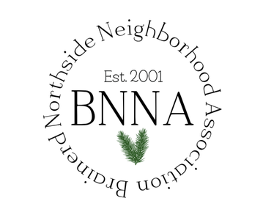
Northside Annual Block Party
First Congregational UCC friends and members are cordially invited to attend The Northside Neighborhood Annual Picnic in Gregory Park is Tuesday, August 9th from 5-7 pm.
The Brainerd Northside Neighborhood Association is a not for profit community based organization encompassing all residents, businesses, non-profits and faith communities residing within the north area of the city of Brainerd.
Wear your T-shirt and meet your neighbors.
Follow their FB Page at https://www.facebook.com/brainerdnorthside/

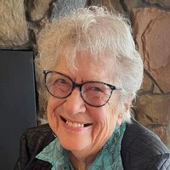
Jean Elizabeth Harrison Widmark Memorial Service
A service of celebration will be held on Friday, August 12th at 1:00 pm at the United Methodist Church in Detroit Lakes with visitation an hour prior, Reverend Kevin Gregory presiding. Burial will take place at Minnesota State Veterans Cemetery, Camp Ripley.
Jean taught school in Brainerd and Pillager and was an active and longtime member of the Congregational (UCC) church in Brainerd and, at her death, a member of the United Methodist Church in Detroit Lakes. Jean was active in her church and serving her community She believed in sharing hospitality and friendship with others.
View details at: https://www.westkjos.com/obituary/jean-widmark

Sharing Bread Soup Kitchen
The Soup Kitchen serve meals daily, 7 days a week at the kitchen. In addition to that, this last winter we started provided breakfast/lunch bags for the homeless population. The kitchen packs the bags and the bags are distributed by the new Warming Shelter and “Our Place”. Most of the items we purchase through the food bank, but there are those items we need to purchase at local retailers like Walmart, Menards, Costco, etc. The items that we really need for donations are tuna and chicken “Snacks on the run” cracker kits. We also could use shelf stable individual items that would typically be pack in a school lunch bag are perfect and would be welcomed. Donations can be brought to the Soup Kitchen (923 Oak St. Brainerd, MN) during serving hours and given to any of the volunteers to put in our office or call 218-829-4203 to plan of other times. Thank you for thinking of the Soup Kitchen.
Follow the Soup Kitchen at: http://sharingbread.com/ or on their Facebook Page: https://www.facebook.com/brainerdsoupkitchen

Save the Date! The Rally for Peace October 1, 2022
Leif Erickson Park
Our 150th Celebration Committee announces a major event, sponsored by Peace, as a gift to our community to celebrate our 150th Anniversary. Keynote speaker David Hogg a survivor of the Marjorie Stoneman Douglas High shooting. Hogg is a co-founder of March for Our Lives. We are looking for volunteers and to include other churches to partner with us. Contact Marsha Hystead (Duluth) at mhystead@haileysault.com or 218-343-0118
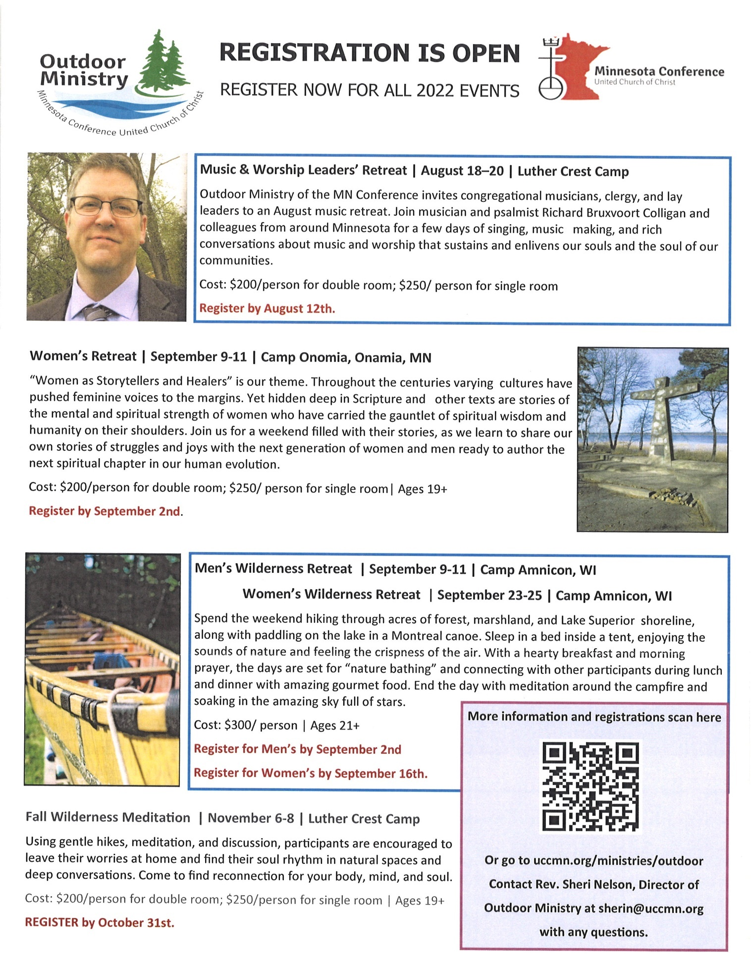

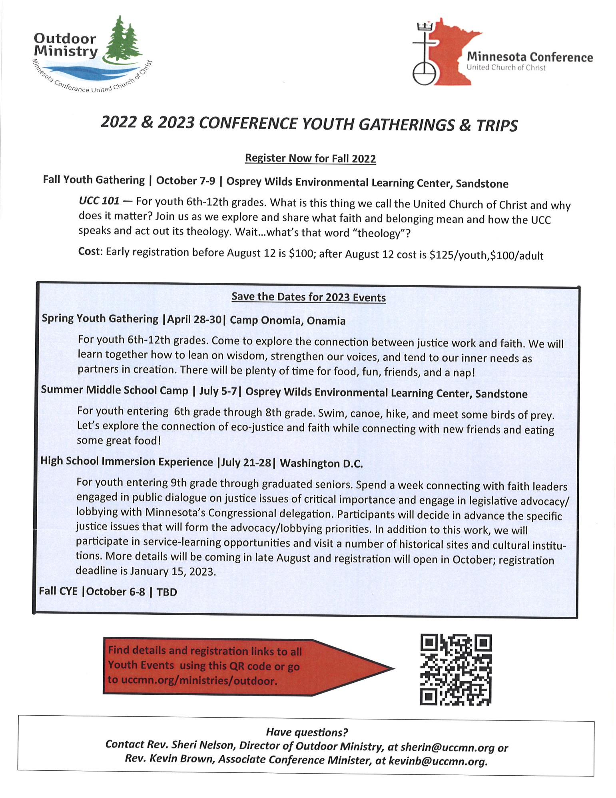
Church Calendar August 2021
Sunday | Monday | Tuesday | Wednesday | Thursday | Friday | Saturday
 | Office Closed  Open by Appt. | Office Closed  Open by Appt. | Office Hours  10am – 1pm  Pastor Drop-in 2-4pm | Office Hours  10am – 1pm | Office Hours  10am – 1pm  Pastor Drop-in  11am-1pm
V or Z– Zoom or Virtual Online  C – Cancelled  Y – Meeting held  ? – No updates | 1  7pm BACP-Park w/chrch backup-Y | 2  2pm Emotions Anon- Y  5:30pm Overeaters Anon- Y | 3  10am Pryr Crcl-Y&Z  12pm Mens Grp-Y  7pm AA Common-Y | 4 | 5  10:30am Bk Grp- Z | 6
9am Brnrd Frnds-Y 7  10am Worship & Communion -Y&V  11am Fellowship -Y  11:30 Confirmation-Y | 8 | 9  2pm Emotions Anon- Y  5-8pm LARJP-Y  5-7pm Nat’l Night Out-Neighborhood Assoc. – our church invited @ Gregory Park  5:30pm Overeaters Anon-Y | 10  10am Pryr Crcl-Y&Z  12pm Mens Grp-Y  7pm Trustees-Postponed  7pm AA Common-Y | 11  6:30 BLUE-Park/church backup-Y | 12  9am Stewardship Mtg.-Z  10:30am Bk Grp- Z  Noon visitation-1:00 Memorial for Jean Widmark Methodist Detroit Lakes | 13
9am Brnrd Frnds-Y 14  10am 150th Culminating Worship-Y&V  11am Fellowship with Anniversary Cake-Y | 15 | 16  2pm Emotions Anon- Y  5:30pm Overeaters | 17 10am Pryr Crcl-Y&Z  12pm Memorial-C  12pm Mens Grp-Y  7pm AA Common- Y | 18  4pm Council Mtg –  7pm AA Dist.-Y | 19  10:30am Bk Grp- Z | 20
9am Brnrd Frnds-Y 21  10am Worship-Y&V  11am Fellowship -Y  11:30 Confirmation-Y | 22  Pastor Leslie begin Renewal time thru 9/28 | 23  2pm Emotions Anon-Y  5pm Le Mesa- Park/ church backup- Y  5:30pm Overeaters Anon-Y | 24  10am Pryr Crcl-Y&Z  12pm Mens Grp-Y  7pm AA Common-Y | 25 | 26  10:30am Bk Grp- Z | 27
9am Brnrd Frnds-Y 28  10am Worship- Y&V  Special Offering  TheShop  11am Fellowship -Y  Newsletter Deadline | 29  . | 30  2pm Emotions Anon-Y  5:30pm Overeaters Anon-Y | 31  10am Pryr Crcl-Y&Z  12pm Mens Grp-Y  7pm AA Common-Y |  | .  *Sun. Bk Stdy on hold  *Choir practice resumes in Sept.  *Girl Scouts #373 resumes in Sept

https://www.who.int/news/item/02-03-2022-covid-19-pandemic-triggers-25-increase-in-prevalence-of-anxiety-and-depression-worldwide
https://www.apa.org/news/press/releases/2022/03/inflation-war-stress

