Friendship News, January 2023
First Congregational United Church of Christ, Brainerd
An Open and Affirming Congregation
The Church Office Hours: Wednesdays – Fridays from 10:00 am – 1:00 pm
Pastor Leslie’s Drop-in Hours: Wed. 1:00pm – 3:00pm, Friday 10:00am – 12:00pm
Office phone 218-829-2528 Office E-mail uccbrainerd@gmail.com Pastor’s E-mail: pastorleslieucc@gmail.com Website: www.uccbrainerdmn.org
Schedule a 1 to 1 (in-person or by Zoom or Phone) with Pastor Leslie:
www.calendly.com/pastorleslieucc/1to1
No matter who you are, or where you are on life’s journey, you are welcome here.

A Resolution Worth Keeping
Not long after the gifts have been opened (and maybe a few returned), talk of New Year’s resolutions begins. Messages like “New Year, New You!” show up in advertising and gym memberships predictably increase. There’s nothing wrong with self-improvement. But we do harm to ourselves and others when we forget that the version of ourselves that exists right now, the “you” who is reading these words, is worthy of love, respect, and compassion, just as you are.
In his first letter to the early churches in Ephesus, the author writes that God is love. He proclaims that we love because God first loved us. There are no conditions on this statement. God’s love is not conditional. God isn’t waiting for us to lose the “holiday weight” to give us love. God isn’t withholding their “agape” from us until we get out of debt. God isn’t stewing in frustration, wondering if this is the year we will quit smoking or get sober or stop hurting people we love before she loves us. We are worthy of that love now. Right now.
Being worthy of love doesn’t mean that God wants us to remain unchanged. Jesus and the prophets constantly call on their people and us to live more faithfully, more lovingly, more justly, more peacefully, more fully. It is good and right to strive to give more to important causes, to volunteer, to work for justice, to have more compassion, to end cycles of abuse, to set and maintain healthy boundaries, and love and forgive ourselves a little more. But none of that, nothing you can do will make God love you any more or any less. Full stop.
So if you make a resolution this year, I invite you to also resolve to love yourself, knowing that God loves you more deeply and more fully than you can possibly imagine. That’s a resolution truly worth keeping.
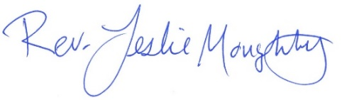
With God’s love and light,

Moderator’s Musings
Two thousand twenty-three (2023) is here! We have so much to look forward to and so much to be thankful for. There is no better way to embrace the fresh start of a new year than to pray for God’s blessings and guidance.
It is a time for reflection and renewal. My hope is that we find peace, comfort and inspiration throughout the year within our families, friends and especially within our church family.
Peace be with you. Happy New Year!

Colleen

0
First Congregational UCC News & Updates
Pastor Leslie is on vacation from 01/02/23 to 01/18/23
Jan Kurtz will lead worship on Sunday January 8
Rev. Mark Blakesly will lead worship on Sunday January 15
For emergency Pastoral care during this time, contact Rev. Mark Ford of Lakes Area Presbyterian by calling church 218-828-6069 or cell 218-232-8131

New Year Announcements!

Prospective Member Classes Starting February – Dates to be determined
Have you thought about becoming a voting member of First Congregational UCC? Whether you know you definitely want to join or you aren’t sure if joining is right for you, please join Pastor Leslie for the three-session series. You will meet other prospective members, hear each other’s faith journeys, learn about the history and governance of United Church of Christ and the history and culture of our congregation. You’ll also learn about healthy and unhealthy communication in a faith community, as well as what you can expect from your church and what will be expected of you! Classes will be held on Sundays after worship.
Annual Connection Letter
At the end of January, our church will be sending out a letter for you to fill out and return. This information will help us update the directory, make informed decisions about programs, and much more. Your response will help us better connect with one another and better serve our members and visitors. So keep your eyes on your mail box!

How to watch Sunday worship The worship service is broadcasted on the church Facebook page and the church's YouTube channel every Sunday at 10:00 am.
To watch worship on Facebook, go to https://www.facebook.com/uccbrainerd/live
Live stream videos are saved and can be viewed at any time.
Financial Help Available Your Church Council voted last year to allow the Pastor's Discretionary Fund to be used to assist church members and others in the Brainerd area who are experiencing financial distress during this time. We received many generous donations! If you need assistance, please email, call, or text Pastor Leslie. Let her know what your situation is and how the church might be of help.
Donate to the church online! We are now accepting your offerings and donations using PayPal. You do not need to have a PayPal account to make an online donation with a credit card. To use PayPal, go to: https://www.paypal.me/uccbrainerd
January Birthdays

Lilja Behr January 1 Marcia Ferris January 13
Linda Downs January 5 Betty Alderman January 16
Macyn Harder McBroom January 7 David Schaeffer January 26
Deb Lundberg January 8 Nick Kalinoski January 31

Church Office Hours
Wednesday, Thursday and Fridays - 10:00 am to 1:00 pm.
Please call Terri at the office 218-829-2528 or cell 218-537-1636 for further assistance.
Pastor Leslie’s drop-in hours* are as follows:
Wednesdays 2:00 pm – 4:00 pm
Fridays 11:00 am – 1:00 pm

*To make an appointment outside of the drop-in hours, go to calendly.com/pastorleslieucc/1to1 to schedule an appointment, or call or email Pastor Leslie directly.

Church Leadership
Get Involved, Give Back, Grow Connections – Volunteer at Church!

The First Congregational UCC’s Foundation is looking for a volunteer to join the Board.
It is a great job – only 4 meetings a year, usually via Zoom. The Board receives requests for funding, evaluates requests and either accepts or rejects requests based upon the by-laws of the Foundation Board and the dollar amount requested.
The Board may request more information before a decision is made to accept or reject.
The best part of being on the Board is that its members get to spend money!
If you are interested or would like more information, contact Lisa Wigand, president, at (218)330-8477 or lisawdavet@outlook.com.

There are many other opportunities for you to share your talents!
--Treasurer, serves a 1-year term (may renew for 6 terms). The primary role is oversight of bookkeeping, church finances and Executive Committee discussions. This candidate should have a strong background or interest in finance or banking.

--Council Member-At-Large: Attend council meetings, act as a liaison for church members and council, help with nominations, spokesperson for historically underrepresented groups (HUGS).

Committees needing fresh faces and leadership:
-Christian Education -Trustees -Stewardship -Memorial
-Music -Arts -Christian Ministry

Call or text Colleen LeBlanc - Moderator, with your nominations: 218-251-4065

Highlights from the Council Meeting, December 15th, 2022
4:00 pm (In-person and Zoom)
~ These are highlights. If you would like a copy of the full minutes, please contact the church office ~

Present: Colleen LeBlanc, Terri Chidester (virtual), Deb Griffith, Leslie Moughty, Marina Grabowski, Marcia Ferris, Karen Ford, Tim Anderson (virtual) Absent: Alvin Velsaag
Report Highlights:
Additions to the Agenda – 2023 Special Sunday Offerings and Facility Use Report
Clerk Report – Karen – No report
Financials
- November financial reports – Balance Sheet shows that end of year donations have improved the total donations for the year. Expenses are higher than budgeted. In mid-January reconciliations will be done by Terri and Yvonne and reported to the council in February. The November financial report was accepted by consensus.
- Update on ‘investments” – Colleen –The CD that was at Bremer has been cashed in with the cash being deposited in the UCC’s money market account at MidMinnesota Credit Union.
- The special offering changes for 2023 were approved.
- Food donations are still being collected. The box will be moved to the narthex and the new location will be announced in the monthly newsletter.
Pastor Report – Pastor reported that during November she dealt with health and housing issues of members and non-members of the congregation. She has written and sent a letter to 80 households informing them of her divorce. Christian Ministry will be managing the worship for the second and third Sundays in January when Pastor will be on vacation. Jan Kurtz will be the leader of one Sunday and a leader for the second Sunday has not yet been determined. Health insurance for Pastor is still being researched. The current Pension Board plan will continue to the end of January with a new plan to be determined beginning in February for Pastor.
Member at Large Report – Alvin (represented by Lowell) – The non-profit “My Neighbor to Love” and the WISE group are possible partners in mental health resources available for residents of the new neighborhood. A forum will be planned in the future when this collaboration is announced.
Department Reports – anything new to add to written reports?
- Trustees – Deb Griffin
- Stewardship – Marcia or Judy – Currently about 70 units are donating.
- Christian Ministry – Marina – Readers needed for Christmas Eve service.
- Christian Education – Lowell Johnson
Old Business
- Technology - Request for funds ($3-5K) will be made to the Foundation in January. The tech group is working to get hard numbers prior to the January 11 Foundation meeting. The Council supports application for funding from the Foundation to improve technology.
- Facility Policy Update – Colleen presented the current draft and requested the council to review and suggest fees and costs to be incorporated into the policy. Terri suggested that the current non-profits meeting regularly be grandfathered into the policy. It was also suggested that a training program be prepared for users of technology when meeting in the church.
- Cleaning/purging in counting room and other storage spaces-Cynthia will keep the Council in the loop. A committee will be formed, and a plan outlined. Cynthia will meet with John Erickson who does archivist work for the School District and with Jeff Behr for assistance.
- Proceeding with department by-laws revisions – Exec committee will discuss in January.
- Manual of Church –Council is advised to review by January meeting
https://youtu.be/OsNdRYFIHig
- Development of Care Team – Leslie will initiate and coordinate. Barb Hoeft may be interested in assisting with a Care Team.
New Business
- January Agenda – Steve Newcom – Steve will explain “privilege of call”. Pastor Leslie said he is looking to have a volunteer position. More to come in January.
- Membership Count – Process is needed to determine voting status for conference reports, etc. Letters will be mailed in January to persons regarding status (active or inactive) in their membership. Data from letters will be added to computer program in March. Council will review in April. Council will need numbers by April to be prepared for the Annual Meeting in May where a quorum will be necessary for voting.
- A request for use of building facilities was received from the Lakes Area Music Festival for the January 7, 2023 Board Meeting from 9am to 12noon. The request was approved. Cynthia Janes is the contact person for the LAMF.
In the “Parking Lot”
- Visioning of church’s future directions, organization, etc.
- Social Media - Conference does not have guidelines - What next?
https://uccfiles.com/pdf/ASF-SocialMediaGuidelines.pdf
- Creation Justice - Ensuring all that we can to reduce our waste/improve our interactions with nature. Jan Kurtz’s info on Creation Justice - When to start this discussion at Council.
Minutes written and respectfully submitted by Karen Ford, Clerk and Secretary to the Council

Next Regular Council Meeting: Friday, January 19th, 2023, 4:00 pm
in-person and via Zoom tinyurl.com/uccbrainerdzoom

TheShop Meal
January 4th - 3:45 pm church kitchen.
We meet once a month on the first Wednesday.
We are working with the young people from TheShop (Brainerd/Baxter's Youth Empowerment Center) and are preparing a meal and serving it at TheShop for the participants in the program.
We have a new volunteer and point person Mary Benson. If you are interested in helping,
please email Mary Benson at marybenson75@gmail.com

De-greening the hurch

VOLUNTEERS NEEDED to take the tree down and the other Christmas greens and move everything to storage for next year. Please take an hour or so on Saturday, January 7th at 10:00 am and join in the fun! THANKS FOR VOLUNTEERING!

Christmas Flowers Removed

Christmas flowers can be removed from the sanctuary on
Sunday, January 8th after worship.
The donors of the plants get first choice!

W.I.S.E. Group to Meet

Our Welcoming, Inclusive, Supportive and Engaged around mental health (WISE) group will be meeting on Sunday, January 15th after worship in the fellowship hall. We will begin planning for our 2023 efforts. All are welcome to attend.

Renewal Support Team

The support team meets January 22nd and January 29th after worship at 11:30 am to begin preparation of submission for Pastor Leslie’s 2024 Sabbatical.

January Adult Forums – 11:30 am after worship

January 8th - Higher Power? What's That?
In 12 step recovery groups, one idea participants discuss is their understanding of Higher Power and its impact on their lives. Join us as some of our friends in recovery discuss their understanding of Higher Power and how that concept helps their process of getting and keeping sober.
January 15th - Rev. Mark Blakesly serves as an ONA (Open and Affirming) consultant for the Minnesota Conference. He will lead an adult forum on a topic related to LGBTQ.
January 29th - Ethical Wills - Leaving a Legacy Beyond Money: Beyond a Legal Will and a Health Care Directive, Ethical Wills are a way to share your values, blessings and life lessons, hopes and dreams for the future, love and forgiveness for your family, friends and community. Ethical Wills are not legal documents. They are not new - read Genesis Chapter 49 and John Chapters 15-18.
An Ethical Will can be one of the most cherished and meaningful gifts you can leave to your family and community. They can be read at your funeral or memorial service. Marcia Ferris will lead this discussion and have a template to get you started, as well as a handout for creating your Personal Mission Statement, which will help you focus on what you believe is the purpose of your life.

UCC Men’s Group - Every Wednesday at Noon
You are invited to a casual fellowship at various locations in the Brainerd Lakes area.
New rotating schedule begins January 2023
First Wednesday: B-Meri
Second Wednesday: El Tequila
Third Wednesday: Dunmire’s East
Fourth Wednesday: Black Bear
Fifth Wednesday: Wings Airport Café

Contact Jack Kraywinkle for more information 612-396-3480 or email: kraywinklej@gmail.com

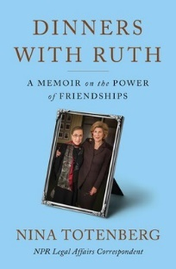
Friday Book Group - 10:00 am
Via Zoom: tinyurl.com/uccbrainerdzoom
The Book Group is currently reading “Dinners with Ruth: A Memoir on the Power of Friendships” by Nina Totenberg.
FYI: The next book will be The Book of Gutsy Women: Favorite Stories of Courage and Resilience by Hillary and Chelsea Clinton.

Cooking For Everyone
This group is OPEN FOR EVERYONE!
Email Lowell johnsonlowells@gmail.com and he will add you to the member list so that you will know when and where we will next meet.

Special Offering Sunday Worship January 23rd
The Bridge on 7th – Warming Shelter
Bridges of Hope, in partnership with law enforcement, Crow Wing County, nonprofit organizations, church partners, and community members recognized the need for a safe place for homeless adults (ages 18+) to sleep in our community. This group has come together in a collaborative effort to address homelessness by providing a low-barrier warming shelter that offers a safe place for individuals to rest for the night.
Please send your donation to First Congregational UCC, 415 Juniper St. Brainerd, MN 56401. Or for your convenience use our Paypal account at: paypal.me/uccbrainerd
Make sure to note on your offering: “Special Offering Warming Shelter”. Thank you!

Volunteers for the Warming Shelter
First Congregational has a new point person for volunteering at the Warming Shelter. Please call Deb Griffith for more information at 218-851-2949.
Sign up link: https://whocanbethere.com/SignUp/week-of-dec-4/1V4mz3t0wPg
Training video: https://ministrygrid.lifeway.com/#/easy-link/WPGQ/45c4e6e3-e5dd-4aee-ab62-1f71c6a061bf
Hosts, Ushers, Greeters, Scripture-readers

Sunday morning greeters/ushers and coffee hosts play an important part in making our church a warm and welcoming place for all. Here’s a secret; it’s FUN!! If each household committed to 3 Sundays a year as greeter/ushers and/or coffee hosts we would have a full complement of participants. For instance, I plan to take 2 Sundays in August to greet/usher and 2 Sundays in February to Host Coffee.
The Christian Ministry Committee is working on simplified instructions for these duties and one of us will be available to guide you through your first go if needed. Are you ready to take the leap into RADICAL HOSPITALITY? Give it a go and signup below for your first Sunday as the face of the church! https://www.signupgenius.com/go/10C0E48A9A823A5FFC07-hugs/16034811

First Congregation Food Shelf Collection
Our church continues to collect non-perishable food items for the Salvation Army Food Shelf. There is a box in the Narthex to put your items. Brian Twamley picks up and delivers the food.
Please consider bringing items and donating. You may also send a money donation to the church either by mail or paypal. Make sure to write in memo “ Food Shelf”. Thank you!
Sunshine Cards – Luann Rice
A friendly reminder to send card requests for those who would appreciate a little sunshine in a card…”Get well, thinking of you”, etc. Contact Luann via email or phone or to Terri in the office at uccbrainerd@gmail.com with your request.

Calling all singers and musicians!
We want to include your voice and instruments during the worship services.
Please contact Pastor Leslie.

The Columbarium at First Congregational UCC, Brainerd

The Columbarium is located in the historic space that once was our church’s front entry way.
How appropriate it is that our Columbarium now marks another entry way into a new life — where the Spirits of Love and Truth are always present!
Should you wish to learn more about the purchase of a niche for your own cremains or for the ashes of a loved one, please call the church office at (218) 829-2528 and a packet of materials will be send you via email or regular mail.
The Memorial Committee has prepared the information packet, and it contains all the details you will need as you consider inurnment here at First Congregational UCC.
Have any other questions? Contact Dawn Stattine at dawnstattine@gmail.com

Marcia Ferris Birthday Celebration!
Celebrate Marcia’s 70th Birthday! Saturday, January 14th 4:00 – 7:00 pm.
Northland Arboretum Fireplace Room, Brainerd
Bring your stories! We’ll share stories at 5:00 pm. Appetizers, snacks, cake and beverages including wine and beer. No Gifts.
If you can’t attend in person please send photos for the slideshow or record a video on your phone. *Send photos to dan@danhegstad.com
Large files can be sent via www.easystreetproductions.biz Scroll down to “send large files” button.

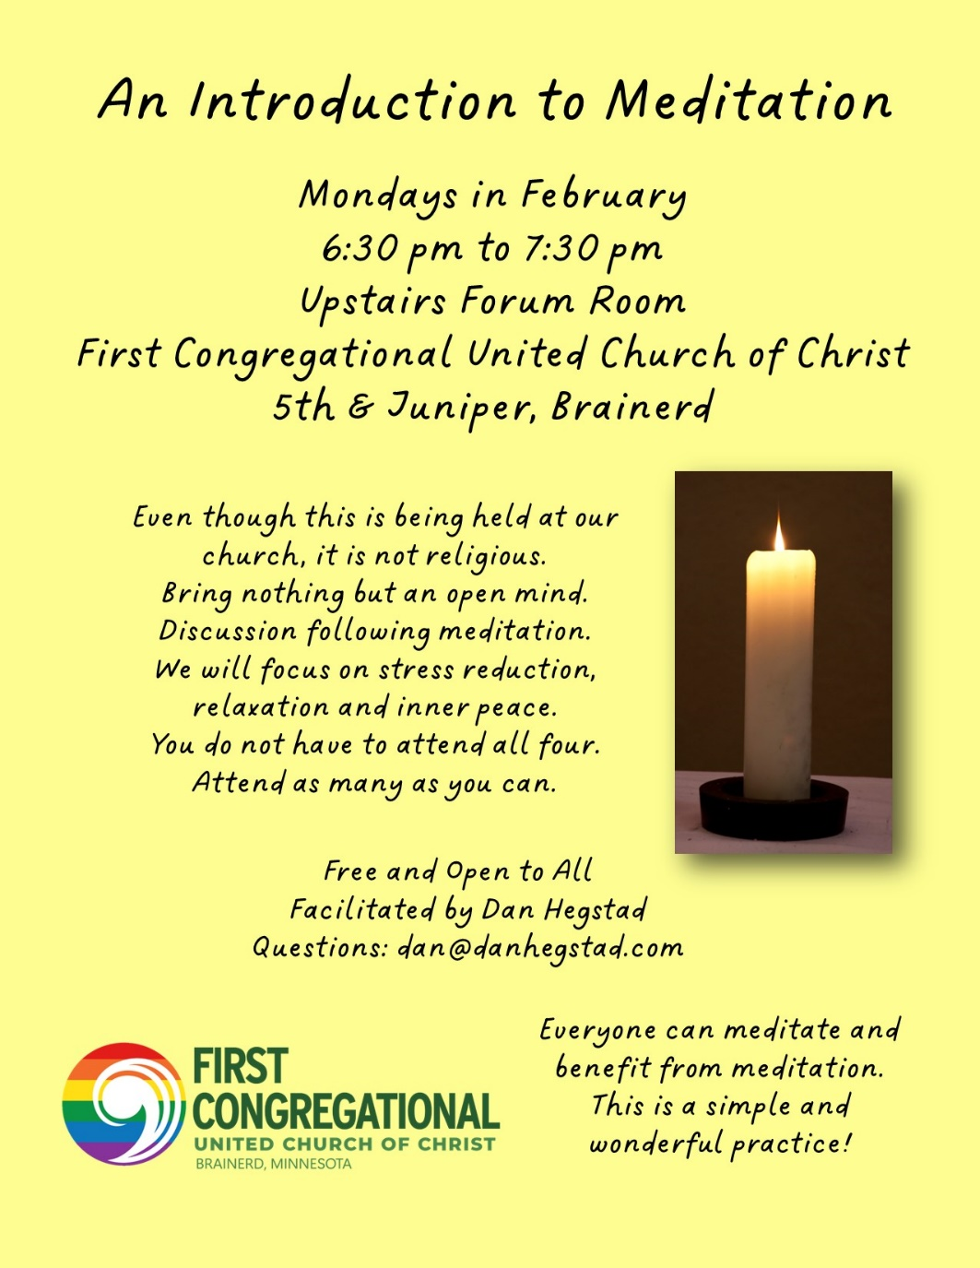

UCC News & Updates!
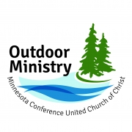
Outdoor Ministry Announces 3rd Annual Winter Zoom Series

﻿Join us for three Zoom gatherings this winter focused on environmental justice issues.
2023 Farm Bill
January 12, 7:00-8:00 pm CST
Presenter: Sarah Goldman
Free; register here to receive the Zoom link
Learn more about the Farm Bill and why it matters to us as a faith community in this one-hour discussion brought to you by the Outdoor Ministry of the MN Conference UCC. The Land Stewardship Project will present the 2023 Farm Bill, which covers health care, food concerns, climate change, and corporate accountability and responsibility. Universities are also affected by this bill through research funding on topics involving agriculture, sustainable practices, and innovation. Read more
Microplastics in the Great Lakes
February 9, 7:00-8:00 pm CST
Presenter: Art Hirsch; Host: Jane Dow
Free; register here to receive the Zoom link
Microplastics in the Great Lakes is an emerging water quality issue that has a huge potential of impacting human health and the aquatic environment. Microplastics are found in our food, water, air, and even beer along the Great Lakes. Fish are ingesting microplastic that cause them to starve and allow microplastics to move up the food chain. Humans are ingesting plastics made from endocrine disruptor chemicals. Read more

Young Adult Winter Retreat Set for January 27 – 29
Who: Ages 18 (post-graduate) through 25
When: January 27-29, 2023| begins at 6:00 pm Friday and ends 11:00am on Sunday
Where: Green Lake Lutheran Camp| Medayto Lodge, Spicer, MN
Cost: $50/person | $25/ person scholarship, if needed; please contact Rev. Sheri Nelson at sherin@uccmn.org
REGISTER HERE Registration is open now until January 20 or when spaces are filled.
After three years apart, Outdoor Ministry is back with a retreat just for young adults ages 18 (post-graduate) through 25. Reconnect with UCC camp friends for a weekend at Green Lake Lutheran Camp in Spicer, MN. This is a chance to relax, have some fun, create a meal together, and help plan the future for young adult programming in the MN Conference.

Register for July 2023 Youth Trip to Washington, D.C.
Students from Conference congregations currently enrolled in grades 8-12 will travel to Washington, D.C., for a service-learning experience focused on the work of legislative advocacy.
- Lobby members of congress and their staff about issues selected by the youth
- Visit monuments, memorials, and museums such as the Frederick Douglas National Historic Site, Martin Luther King Jr. Memorial, and U.S. Holocaust Museum and Memorial
- Learn about root causes of systemic oppression through direct service
- Have time for fun, reflection, and conversations that matter!
Learn more and register: https://www.uccmn.org/event/summer-2023-youth-trip-to-washington-dc/

January 2023 Calendar
Sunday | Monday | Tuesday | Wednesday | Thursday | Friday | Saturday
 | Office Closed  Open by Appt. | Office Closed  Open by Appt. | Office Hours10am – 1pm  Pastor Drop-in  1pm-3pm | Office Hours  10am – 1pm | Office Hours10am – 1pm Pastor Drop-in  10am-12pm
8:30am Bnrd Frnds-Y 1  10am Wrship & Communion-Y&V  11am Fellowship-Y  11:30am CM Mtg.-Y | 2  12pm Vets Bk Grp-Z  7pm BACP- V | 3  2pm Emotions Anon- Y  5:30pm Overeaters Anon-Y | 10am Pray Crcle-Y 4  12pm Mens Grp@ B-Meri-Y  3:30pm TheShop Cooking-Y  7pm AA Common-Y | 5 | 6  10:30am Book Grp-Z | 7  9am Lakes Area Music Festival Brd Dir Mtg-Y  10am De-greening the church-Y
8  8:30am Bnrd Frnds-Y  10am Wrship-Y&V  Jan Kurtz leads worship  11am Fellowship-Y  11:30 am Adult Forum-Y | 9  12pm Vets Bk Grp-Z | 10  2pm Emotions Anon- Y  5:30pm Overeaters Anon- Y | 10am Pray Crcle-Y 11  12pm Mens Grp@  El Tequila-Y  12pm Memorial Y&Z 2pm Foundtn Mtg-Z 7pm AA Common-Y | 12  8:30am CM Mtg-Y  3pm Trustees- Y  6:30pm BLUE -Z | 13  10:30am Book Grp-Z | 14  Marcia Ferris Birthday Celebration 4-7pm  Arboretum/Fireside Room
8:30am Bnrd Frnds-Y 15  10am Wrship-Y&V  Rev. Mark Blakesly  11am Fellowship-Y  11:30am Adult Forum-Y  11:30 am WISE Grp-Y | 16  12pm Vets Bk Grp-Z | 17  2pm Emotions Anon-Y  5:30pm Overeaters Anon-Y | 18  10am Pray Crcle-Y 12pm Mens Grp @ Dunmire’s East-Y  7pm AA Common-Y | 19  4pm Council Mtg-Y&Z  7pm AA Dist-Y | 20  10:30am Book Grp- Z | 21
8:30am Bnrd Frnds-Y 22 10am Wrship-Y&V  11am Fellowship-Y  Special Offering:  Bridge on 7th  **Newsletter Deadline** | 23  12pm Vets Bk Grp-Z | 24  2pm Emotions Anon-Y  5pm LeMesa-V  5:30pm Overeaters Anon-Y | 25  10am Pray Crcle-Y  12pm Mens Grp@ Black Bear-Y  7pm AA Common-Y | 26 | 27  10:30am Book Grp- Z | 28
8:30am Bnrd Frnds-Y 29 10am Wrship-Y&V  11am Fellowship-Y  11:30 am Adult Forum-Y | 30  12pm Vets Bk Grp-Z | 31 |  |  | *Pastor Leslie is on vacation 01/02/23 - 01/18/22 | V or Z –Virtual Online or our Zoom  C- Cancelled  Y- Yes Mtg. in person  N-None  ? – No update

