Friendship News, February 2020
First Congregational United Church of Christ, Brainerd
An Open and Affirming Congregation
Church office hours: Wednesday - Friday 8am 12:00pm
Office phone 218-829-2528 Office E-mail uccbrainerd@gmail.com Pastor’s E-mail: pastorleslieucc@gmail.com Website: www.uccbrainerd.org
To schedule a 1 to 1 with Pastor Leslie: www.calendly.com/pastorleslieucc/1to1
No matter who you are, or where you are on life’s journey, you are welcome here.

Pastor’s Pen

Every January for the last 4 years I have been blessed to travel to Carefree, Arizona for leadership classes. Four and a half years ago I was selected to participate in an incredible program through the United Church of Christ called The Next Generation Leadership Initiative or NGLI for short. The program, sponsored by the Pension Boards of the UCC, “has emerged as a leadership development initiative that equips, energizes, and empowers younger UCC local church pastors to build vibrant congregations that change lives and further God’s mission in the world.” You can read more and watch a short video about the program at https://www.pbucc.org/index.php/ngli.
Each year, we focus on a different topic for our January session. This year’s focus was “Faithful and Fruitful Ministry.” We read 4 different books, but our guiding text was a book called Five Practices of Fruitful Congregations by Robert Schnase. This book and our class sessions inspired and excited me for the possibilities of what our church can do! I have decided (with the encouragement of the Church Council) to share some of the learnings from that book and our sessions each month in this newsletter as well as in Adult Forums.
The Five Practices are as follows: 1. Radical Hospitality 2. Passionate Worship 3. Intentional Faith Formation 4. Risk Taking Mission and Service 5. Extravagant Generosity. But The first lesson in the book is not one of the practices, but rather about a big shift in the nature of church that has been happening and to which we must adapt. (I also think this shift is more in line with the way Jesus calls us to be his disciples.) That shift is from being primarily a “Come and See” church, to increasingly being a “Go and Do” church. Schnase writes, “People want to do something that matters and belong to a church that makes a difference.” Schnase also talks about the need to expand our thinking beyond “attractional” assumptions. In the first edition of the book, he wrote “Churches that practice radical hospitality ‘take the initiative to invite, welcome, include, and support newcomers.’” Schnase notes that while attractional models of doing church are helpful and necessary, they are not enough: “Faith communities must also develop ministries that derive from missional assumptions, activities that primarily benefit people who are not members of the church, often in places far away from church facilities. These ministries require a different posture toward our neighborhoods, a more deliberate outward focus, and a willingness to carry Christ’s love to where people already live, work, and play rather than hoping for people to come to us.”
In the past, attractional models worked because the culture expected people to attend worship and people wanted to be members of churches. But what happens when people are losing trust in institutions in general and the church in particular? When a majority of people around us have little or no experience in worship, no familiarity with scripture, or have experienced a type of church in the past that did them harm? Schnase reminds us that not only did Jesus welcome the stranger, he also became the stranger who accepted the welcome of others in order to offer them God’s grace. We are already doing some of what Schnase suggests in his book, but we have so much potential to more fully live into a vision truly fruitful ministry.
Starting in March, the entire church is invited to join in a book study of Five Practices. We will read together on a schedule and then come together during adult forums and over the fellowship hour to discuss how the lessons in the book might apply to each of us as individuals and as a whole congregation. Paperback copies of the book as well as e-books can be ordered through most major book sellers. (Just make sure you order the Revised and Updated version. This is extremely important.) We will be taking orders for a bulk order from Cokesbury using our tax exemption. A sign-up sheet will be in the narthex as well as online here: https://tinyurl.com/5bookorder

I am excited to venture into this learning with you, to explore the ways we are each called to be disciples, sent by God to carry the love of Christ into every place we go with intentionality, grace and humility.
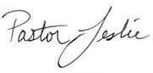

Important Note about Pastor Leslie’s email: When emailing Pastor Leslie, please make sure you send email to pastorleslieucc@gmail.com. The old email address is no longer active and will not give you an error message. Pastor Leslie is unable to access these emails.

~ Opportunities to Know and Share God’s Love ~

4th Sunday Special Offering – Food Shelf

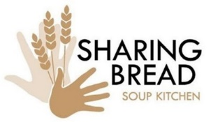
Share the Blessing of Food and Connection at the Soup Kitchen
Our church has the privilege of cooking and serving dinner for hungry neighbors on the 4th Friday of every month. You do not need to know anything about cooking, just come lend a hand and a smile. We typically start by 3:00pm and finish by 7:00 pm. Are you unable to volunteer for the full time? That’s ok! One of the biggest needs is for help with clean up. Arriving at the Soup Kitchen at 5:30 or even 6:00 to help wash dishes, mop, and clean tables would be a huge blessing to the other volunteers! Sign up in the narthex and discover the blessing you will receive when you are a blessing to others. The next opportunity to serve is Friday, February 28th.

February Birthdays

Yvonne Leiser February 2
William Lamont February 7
Annie Grabowski February 7
Roger Best February 10
Dorothy Blau February 11
Roger Maas February 11
Georgia Harris February 15
Mary Reardon February 17
Ann Turnbull February 18
Colleen LeBlance February 24
Ken Moughty February 28
Grace Johnson February 29

HUGS - If you are interested in being a fellowship host, usher, or greeter, contact Jan Morton.
February 2 February 9
Hosts: Jan Morton & Shon Boman Hosts: Tom Nelson & Karen Ford
Ushers/Greeters: Reed Campbell, Ushers/Greeters: Lois McBroom, Itty Newgord
Austin Newgord & Gary Whiteman & Kay Kraywinkle
Counters: Reed Campbell & Judy Whiteman Counters: George Harris & Deb Griffith

February 16 February 23
Hosts: Cynthia Janes & Charlotte Goedsche Hosts: Ann Turnbull
Ushers: Austin Newgord & Itty Newgord Ushers: Ellie Burkett & Tracy Lyons
Greeters: Deb Lundberg & Shirley Barten Greeters: Joey Halverson & Sharon Carlson
Counters: Mabel Schultz & Tracy Lyons Counters: Gale Landem & Cynthia Janes

Liturgists
What is a liturgist? An awesome volunteer who reads aloud portions of the worship service including the Call to Worship and the Scripture.
If you are interested in being a liturgist, please contact Barb Stokke.
February 2: Kelly Keller-Heikkila February 9: Jan Morton
February 16: Shon Boman February 23: Autumn Caldwell
Ash Wednesday – February 26: Open

Update to Council Minutes
Rather than include the full minutes from the monthly council meeting in the church newsletter each month, we will be including a summary of highlights each month that include any important information or votes taken. We hope this will make this portion of the newsletter more readable and shorten the length of the newsletter in total. Please email the church office if you would like to receive a copy of the complete minutes.
Your council members are:
Moderator – Mike North Asst. Moderator – Tracy Lyons Clerk – Barb Stokke Treasurer – Vacant Trustees – Deb Griffith Stewardship – Judy Whiteman
Christian Ministry – Marina Grabowski Christian Education – Lowell Johnson
Members at Large: vacant, Claire Steen, Alvin Velsvaag, and Cassie Lyons
Pastor – Rev. Leslie Moughty

Highlights from the December 2019 Council Meeting
Updates from committees:
- Interviews conducted for new Administrative Assistant.
- Financial Update: The projected 2019 budget deficit of $8,600 had been reduced to about $3,500 because the church has received an additional gift of $5,000.
- New heating system is up and running. AC will be changed over in Spring or sooner. Cost is being paid by money from Millie Gjertson’s bequest to the Foundation and the Memorial Committee.
- Annual pledge drive complete and a few pledges are still coming in.
- Safe Church policy is being developed by a small group of the Council.
Motions:
- Council approved a motion to open a Conservative Raymond James Freedom Q3 account at Bremer Bank with funds formerly held by Stifel Nicolaus. This fund is used to receive and process gifts of stock.
- Council passed a motion to offer the administrative assistant position to Theresa (Terri) Chidester.
- Council passed a motion to approve a salary for Terri of $16.60 for an average 22 hours per week and a contribution $25 a month to the UCC Annuity Fund, if desired.

Highlights from the January 2020 Council Meeting
Updates from committees:
- Terri Chidester accepted the Administrative Assistant position. She trained with Pastor Leslie for 10 hours before Leslie was out of the office for two weeks. Bobbie is still doing all of the bookkeeping and will begin training Terri on these tasks in the next few weeks.
- Pastor Leslie offered 5 pages of notes from her time at NGLI and requested that the council engage in a book study of Five Practices of Fruitful Congregations by Robert Schnase. Council agreed and suggested that the entire congregation participate.
- Trustees approved the repair of the east facing stained-glass window by Gaytee-Palmer at a cost of $22,930. The Foundation Committee has approved funding for the installation of a keyless entry and handicap push button system. Members of the Foundation also requested the installation of panic bars on the east facing two front doors which will require additional information and bids.
- Christian Ministry coordinated the decorating and undecorating of the church for Christmas and organized two worship services while Pastor Leslie attended NGLI and spent time with family. Holy week will be their next focus.
- Christian Education is planning a sledding party tentatively set for February 9. Other activities are in development.
- Council congratulated member-at-large Cassie Lyons for being selected Student of the Semester at Brainerd high school.
- Cassie again brought to the Council’s attention the continued use of Styrofoam in our church, and Leslie reminded Council that the 2019 General Synod in Milwaukee, Wisconsin, passed a resolution against using polystyrene.
- Council discussed the advisability of a review of the church’s finances, which has not been done recently.

Motions:
- Council passed a motion to approve Bobbie Borg Gorron as church treasurer.

ACEs 101 Presentation
People who experience childhood trauma don’t “just get over it.”
Whether you experienced childhood trauma or not, you can help! Learn more at this free presentation.
Monday February 3rd, 2020 5:30 p.m. – 8:00 p.m.
Bethlehem Lutheran Church 418 – 8th Ave. NE Brainerd, MN 56401
FREE DINNER & CHILDCARE
Register here: http://bit.ly/FebACEs2020 218-825-7682
Presented by: Bridges of Hope and Self-Healing Communities Project

Coming Soon… ILLUSION THEATER’S THE PINK UNICORN
DRYDEN THEATRE - Central Lakes College
February 12th, 2020 7:20 p.m.
This award-winning solo piece, Kate Guentzel plays a Christian widow, who must choose sides in her conservative Texas town after her teenage daughter announces she is “gender queer” and starts a chapter of the Gay Straight Alliance at the local high school. Inspired by personal events experienced by the playwright, this story explores what it means to be a parent and a community in these changing times. Includes post-performance Q&A discussion.
Tickets $12 Adult / $8 Under 18 CLCPERFORMINGARTS.COM 218-855-8199

2020 National Youth Event Purdue University, West Lafayette, IN
July 22-25, 2020
Contact Pastor Leslie Initial registration for transportation is due by February 15.
The United Church of Christ's National Youth Event will take place at Purdue University in West Lafayette, Indiana July 22-25th 2020. This 4-day event is celebrated as the UCC's largest denominational gathering. Please make plans to join with youth from across the country for this empowering time together focused on faith, leadership, service and social justice. Youth currently enrolled in grades 6-12 are welcome to register for the event. Registration will be open soon. For more information: http://www.uccpages.org/nye2020/
$375 - event registration & lodging
The Conference will arrange and subsidize the transportation via charter bus from the Twin Cities. The cost for round-trip transportation will be $75/person, thanks to a generous subsidy from the Ashley Endowment. Final participant numbers and individual registration will be completed by April 15, 2020.

Summer Youth Camp 2020

Sunday, June 28th - Wednesday, July 1st

Camp Onomia - 14202 Shakopee Lake Road, Onamia MN 56359
The Holy Bible vs Hollywood: How does current literature, music, and film compare, intersect, and/or influence our understanding of God and Scripture? Multiple speakers will join us throughout our four-day journey of discovery, as we engage in the messages found within stories, such as Harry Potter, music from classical to popular hits, and tv shows and movies, like Stranger Things and Star Wars.
Claire Klein will not only bring us a Harry Potter worship, she will also provide music, along with our “Fly by the Seat of Our Pants” youth band. Claire Klein is a music therapist at Fairview Home Care and Hospice and a UTS alum, where she led the Harry Potter Worship on more than one occasion.
Registration is open now at uccmn.org. Cost is $225. Scholarships Available
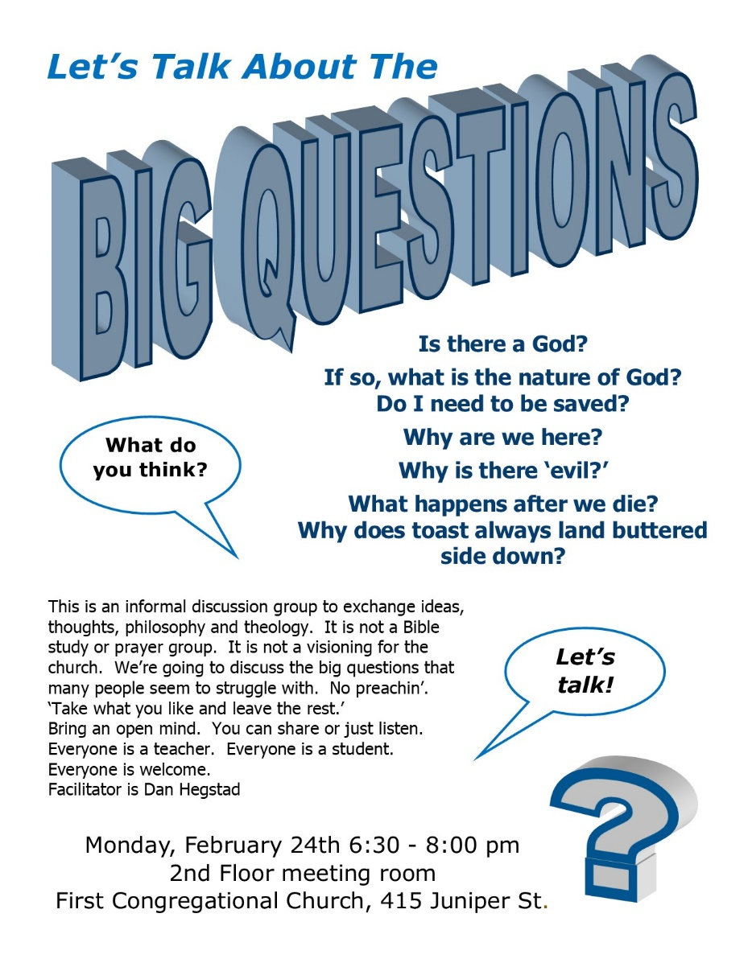
Workshop Series: What does it mean to live sustainably?
Participate in a free series of three sessions entitled: “What Does It Mean to Live Sustainably?” The series will be held on three consecutive Saturdays, 3:00pm-5:00pm beginning March 7 and ending March 21 at Balsam Moon located 10 miles west and south of Pine River on the edge of The Foothills State Forest. This free series is an opportunity to come together and explore these, and more, questions related to sustainability, our worldview, and how to more fully embrace a sustainable lifestyle.
You can register for the sustainability series by calling 218-587-3808, email Doug Weiss at weiss005@umn.edu, or by registering via the Facebook site: Balsam Moon.

Lakes Area Guys Network
A group of men from our community, including six from our congregation, are hoping to start a men's community service group this winter. We hope to be partnering with the Self Healing Communities Project in NE Brainerd, but are willing to serve other geographic areas also.
The basic idea is to build relationships between men who have had mostly fortunate lives with those who have had more bumpier roads in life - specifically men re-entering family and community following incarceration and/or addiction. We will be looking for and developing community service projects, as it is a developmental need of all men to give back to the community in order to be whole and purposeful in life.
One idea is already in the initial planning stages. The community loom project would involve men building looms that would be distributed to various community sites. These looms can be used either indoors or outdoors, and would be used by children and adults to create weavings that can be de-constructed upon completion and then new ones recreated by the next group. The Shop and the Crossing Arts Alliance have already committed to participating, and other community groups, including the school district, are also interested.
For more information, contact Lowell Johnson at 218-820-5290, or johnsonlowells@gmail.com.

Church Calendar February 2020
Sunday | Monday | Tuesday | Wednesday | Thursday | Friday | Saturday
 | Office Closed on Mondays | Office Closed on Tuesdays | Office Open  8:00 am – 12:00 pm | Office Open  8:00 am – 12:00 pm | Office Open  8:00 am – 12:00 pm | 1
2  8:30 Choir Practice  9:00 Brainerd Friends  10:00 Worship & Communion  11:00 Fellowship  11:15 Sunday School  11:30 Adult Forum | 3  4:00 Girl Scouts  6:00 Tai Chi  7:00 BACP (Brainerd Area Coalition for Peace) | 4  2:00 Emotions Anon.  5:30 Overeaters Anon. | 5  9:30 Prayer Circle  12:00 Men’s Group @  Sawmill Inn  7:00 AA | 6 | 7  10:30 Book Group | 8
9  8:30 Choir Practice  9:00 Brainerd Friends  10:00 Worship  11:00 Fellowship  11:15 Sunday School  11:30 Adult Forum  1:00-3:00 BLUE Meeting (Brainerd Lakers United for the Environment | 10 | 11  2:00 Emotions Anon.  5:30 Overeaters Anon. | 12  9:30 Prayer Circle  12:00 Men’s Group @  Sawmill Inn  7:00 AA | 13  3:00 Trustees Meeting  5:00 Stewardship Meeting | 14  10:30 Book Group | 15
16  8:30 Choir Practice  9:00 Brainerd Friends  10:00 Worship  11:00 Fellowship  11:15 Sunday School  11:30 Adult Forum | 17  4:00 Girl Scouts | 18  2:00 Emotions Anon.  5:30 Overeaters Anon. | 19  9:30 Prayer Circle  12:00 Men’s Group @  Sawmill Inn  7:00 AA  7:00 Council Meeting | 20  3:00 The Shop  7:00 AA | 21  10:30 Book Group | 22
23  9:00 Brainerd Friends  10:00 Worship & Special Offering  11:00 Fellowship  11:15 Sunday School  11:30 Adult Forum | 24  5:30 AAUW  6:30 Open Discussion “Big Questions” | 25  2:00 Emotions Anon.  5:30 Overeaters Anon. | Ash Wednesday 26  9:30 Prayer Circle  12:00 Men’s Group @  Sawmill Inn  6:00 Ash Wed Service  7:00 AA | 27 | 28  10:30 Book Group  12:00 Memorial Committee Meeting  4:00 Soup Kitchen | 29

